UNITED STATES
SECURITIES AND EXCHANGE COMMISSION
Washington, D.C. 20549

FORM 8-K

CURRENT REPORT
Pursuant to Section 13 or 15(d) of the
Securities Exchange Act of 1934

Date of Report (Date of earliest event reported): August 5, 2026

INSEEGO CORP.
(Exact Name of Registrant as Specified in Charter)

Delaware |  | 001-38358 |  | 81-3377646
(State or other jurisdiction  of incorporation) |  | (Commission File Number) |  | (IRS Employer  Identification No.)

9710 Scranton Road, Suite 200
San Diego, California 92121
(Address of principal executive offices) (Zip Code)

(858) 812-3400
(Registrant’s telephone number, including area code)

Not Applicable
(Former name or former address, if changed since last report)

Check the appropriate box below if the Form 8-K filing is intended to simultaneously satisfy the filing obligation of the registrant under any of the following provisions:

☐ | Written communications pursuant to Rule 425 under the Securities Act (17 CFR 230.425)

☐ | Soliciting material pursuant to Rule 14a-12 under the Exchange Act (17 CFR 240.14a-12)

☐ | Pre-commencement communications pursuant to Rule 14d-2(b) under the Exchange Act (17 CFR 240.14d-2(b))

☐ | Pre-commencement communications pursuant to Rule 13e-4(c) under the Exchange Act (17 CFR 240.13e-4(c))

Title of each class | Trading Symbol(s) | Name of each exchange on which registered
Common Stock, par value $0.001 per share | INSG | Nasdaq Global Select Market

Indicate by check mark whether the registrant is an emerging growth company as defined in Rule 405 of the Securities Act of 1933 (§230.405 of this chapter) or Rule 12b-2 of the Securities Exchange Act of 1934 (§240.12b-2 of this chapter).

Emerging growth company ☐

If an emerging growth company, indicate by check mark if the registrant has elected not to use the extended transition period for complying with any new or revised financial accounting standards provided pursuant to Section 13(a) of the Exchange Act. ☐

Item 2.02. | Results of Operations and Financial Condition.

On August 5, 2026, Inseego Corp. (the “Company”) issued a press release containing preliminary financial results for the quarter ended June 30, 2026. On August 5, 2026, the Company also posted an investor presentation to its website at https://investor.inseego.com/events-presentations (the “Company Earnings Presentation”). The text of the press release and Company Earnings Presentation are furnished as Exhibits 99.1 and 99.2 to this Form 8-K and incorporated herein by reference.

The information in “Item 2.02 Results of Operations and Financial Condition” of this Current Report on Form 8-K and in Exhibit 99.1, attached hereto, is furnished and shall not be deemed “filed” for purposes of Section 18 of the Securities Exchange Act of 1934, as amended (the “Exchange Act”), or otherwise subject to the liabilities of that section. It may be incorporated by reference in a filing under the Exchange Act or the Securities Act of 1933, as amended, only if such subsequent filing specifically references such disclosure in this Form 8-K.

Item 9.01. | Financial Statements and Exhibits.

(d) Exhibits.

The following Exhibits are filed with this report:

Exhibit No. | Description
99.1 | Press Release dated August 5, 2026, containing Inseego Corp. preliminary financial results for the quarter ended June 30, 2026
99.2 | Company Earnings Presentation, dated August 5, 2026
104 | Cover Page Interactive Data File (embedded within the Inline XBRL document).

2

SIGNATURE

Pursuant to the requirements of the Securities Exchange Act of 1934, the registrant has duly caused this Current Report on Form 8-K to be signed on its behalf by the undersigned hereunto duly authorized.

 | INSEEGO CORP.
 | By: | /s/ Steven Gatoff
 |  | Steven Gatoff
 |  | Chief Financial Officer
Date: August 5, 2026

3

Exhibit 99.1


Inseego Reports Second Quarter 2026 Financial Results

Q2 2026 revenue of $44.0 million

Q2 2026 Adjusted EBITDA* of $0.5 million and GAAP Net Loss of $8.4 million

SAN DIEGO, August 5, 2026 (GLOBE NEWSWIRE) -- Inseego Corp. (Nasdaq: INSG) (the “Company”), the cloud-first wireless edge company, today reported its results for the second quarter of 2026 ended June 30, 2026.

“We delivered revenue ahead of guidance in Q2, reflecting benefits from the diversification of both our customer base and product portfolio this past year,” said Juho Sarvikas, CEO of Inseego. “A key operational milestone was reached in Q2 as we have now launched our refreshed Mobile product family across all three North American Tier-1 carrier customers, a significant accomplishment in the Company’s history. As we move into the second half of 2026, our focus is on converting the launched product portfolio into revenue, improving gross margins, strengthening our engineering and product delivery, and aligning costs with the revised revenue profile.”

Steven Gatoff, CFO of Inseego, added: “We delivered sequential and year-over-year revenue growth in Q2, and Adjusted EBITDA within our guided range. We continue to work towards the anticipated Q4 2026 closing of the FWA acquisition with Nokia.”

Q2 2026 Financial Highlights

 | • | Total revenue for Q2 2026 was $44.0 million.
 | • | Adjusted EBITDA* for Q2 2026 was $0.5 million. GAAP Net Loss was $8.4 million.
 | • | GAAP gross margin for Q2 2026 was 33.8%.

Business Highlights

 | • | Expanded the MiFi PRO M4 across all three major U.S. carrier networks through launches with AT&T, T-Mobile, and Verizon, strengthening Inseego’s mobile broadband position in the business mobility market.
 | • | Broadened MiFi PRO M4 availability with a new unlocked, multi-carrier model available through select VARs, extending Inseego’s reach through the channel and supporting flexible enterprise and public sector deployments.
 | • | Selected Amsterdam as its center for international operations and announced the appointment of Pranav Shroff as Senior Vice President and Managing Director, India and Asia-Pacific (APAC) Sales, and Ossi Korpela as Senior Vice President and Managing Director, Europe, Middle-East, and Africa (EMEA) Sales.
 | • | Expanded our working capital facility with BMO Bank from $15.0 million to $20.0 million.

1

Investor Events

Inseego management will be participating in the following upcoming investor events:

 | • | September 10, 2026 – Lake Street Capital Markets 10th Annual Best Ideas Growth Conference (New York, NY)

Q3 and Full-Year 2026 Guidance

 | – | Q3 2026 total revenue in the range of $28.0 million to $35.0 million.
 | – | Q3 2026 Adjusted EBITDA* in the range of negative $2.0 million to negative $1.0 million.
 | – | Full-year 2026 total revenue of approximately $155 million.

Conference Call Information

Inseego will host a conference call and live webcast today at 5:00 p.m. ET. A Q&A session will be held live directly after the prepared remarks. To access the conference call:

 | • | Online, visit https://investor.inseego.com/events-presentations
 | • | Those without internet access or unable to pre-register may dial in by calling:

 | • | In the United States, call 1-844-282-4463
 | • | International parties can access the call at 1-412-317-5613

An audio replay of the conference call will be available one hour after the call through August 19, 2026. To hear the replay, parties in the United States may call 1-855-669-9658 and enter access code 7903540 followed by the # key. International parties may call 1-412-317-0088. In addition, the Inseego Corp. press release will be accessible from the Company's website before the conference call begins.

*Adjusted EBITDA is a non-GAAP financial measure. See “Non-GAAP Financial Measures” below for more information, and the tables at the end of this release for a reconciliation to the closest GAAP measure.

About Inseego Corp.

Inseego is a leader in cloud-first wireless edge solutions, delivering secure, resilient connectivity across people, places, and machines. As wireless becomes foundational infrastructure, Inseego unifies connectivity, management, security, and subscriber lifecycle management into a platform that orchestrates cellular, satellite, Wi-Fi, and emerging wireless technologies at the edge.

Its portfolio includes 5G fixed wireless access routers, MiFi mobile hotspots IoT solutions under the Skyus brand, and cloud platforms including Inseego Connect and Inseego Subscribe, all designed in the U.S. Built on its core strength and long-term leadership in cellular technology, Inseego solutions enable service providers and channel partners to deploy and manage enterprise-grade wireless solutions at scale. Learn more at www.inseego.com.
© 2026. Inseego Corp. All rights reserved. The Inseego name and logo are trademarks of Inseego Corp.

2

Cautionary Note Regarding Forward-Looking Statements

Some of the information presented in this news release may constitute forward-looking statements within the meaning of the Private Securities Litigation Reform Act of 1995. In this context, forward-looking statements often address expected future business and financial performance and often contain words such as “may,” “estimate,” “anticipate,” “believe,” “expect,” “intend,” “plan,” “project,” “will” and similar words and phrases indicating future results. The information presented in this news release related to our financial guidance, future business outlook, the future demand for our products, and other statements that are not purely historical facts are forward-looking. These forward-looking statements are based on management’s current expectations, assumptions, estimates, and projections. They are subject to significant risks and uncertainties that could cause results to differ materially from those anticipated in such forward-looking statements. We, therefore, cannot guarantee future results, performance, or achievements. Actual results could differ materially from our expectations.

Factors that could cause actual results to differ materially from the Company’s expectations include: (1) the Company’s dependence on a small number of customers for a substantial portion of our revenues; (2) the future demand for wireless broadband access to data and device management software and services and our ability to accurately forecast; (3) the growth of wireless wide-area networking and device management software and services; (4) customer and end-user acceptance of the Company’s current product and service offerings and market demand for the Company’s anticipated new product and service offerings; (5) our ability to develop sales channels and to onboard channel partners; (6) increased competition and pricing pressure from participants in the markets in which the Company is engaged; (7) dependence on third-party manufacturers and key component suppliers worldwide; (8) the impact of fluctuations of foreign currency exchange rates; (9) the impact of supply chain challenges on our ability to source components and manufacture our products; (10) unexpected liabilities or expenses; (11) the Company’s ability to introduce new products and services in a timely manner, including the ability to develop and launch 5G products at the speed and functionality required by our customers; (12) litigation, regulatory and IP developments related to our products or components of our products; (13) the Company’s ability to raise additional financing when the Company requires capital for operations or to satisfy corporate obligations; (14) the Company’s plans and expectations relating to acquisitions, divestitures, strategic relationships, international expansion, software and hardware developments, personnel matters, and cost containment initiatives, including restructuring activities and the timing of their implementations; (15) the global semiconductor shortage and any related price increases or supply chain disruptions, (16) the potential impact of COVID-19 or other global public health emergencies on the business, (17) the impact of high rates of inflation and rising interest rates, (18) the impact of import tariffs on our materials and products, and (19) the impact of geopolitical instability on our business.

Additionally, in connection with Inseego’s planned acquisition (“Proposed Transaction”) of Nokia’s Fixed Wireless Access business (the “Business”), factors that may cause actual results to differ materially from current expectations include, but are not limited to: (1) the occurrence of any event, change or other circumstances that could give rise to the termination of the Asset Purchase Agreement with respect to the Proposed Transaction, (2) the outcome of any legal proceedings that may be instituted against the parties following the announcement of the Proposed Transaction; (3) the inability to complete the Proposed Transaction, including due to failure to satisfy any conditions to closing; (4) the risk that the announcement and/or consummation of the Proposed Transaction disrupts Inseego’s current plans or operations; (5) the ability to recognize the anticipated benefits of the Proposed Transaction, which may be affected by, among other things, the potential loss of customers and/or employees of the Business, competition, and/or the ability of Inseego to grow and manage growth profitably; (6) the risk that Inseego will not be able to integrate the Business successfully; (7) the risk that costs savings and other anticipated synergies from the Proposed Transaction may not be realized when expected, or at all; (8) the diversion of Inseego’s management’s time on issues related to the Proposed Transaction.

These factors, as well as other factors set forth as risk factors or otherwise described in the reports filed by the Company with the SEC (available at www.sec.gov), could cause results to differ materially from those expressed in the Company’s forward-looking statements. The Company assumes no obligation to update publicly any forward-looking statements, even if new information becomes available or other events occur in the future, except as otherwise required under applicable law and our ongoing reporting obligations under the Securities Exchange Act of 1934, as amended.

3

Non-GAAP Financial Measures

Inseego Corp. has provided financial information in this press release that has not been prepared in accordance with GAAP. Non-GAAP net income (loss) and non-GAAP net income (loss) per share, for example, exclude the impact of share-based compensation expense, impairment of capitalized software, amortization of intangible assets purchased through acquisitions, non-recurring transaction related costs, and other non-recurring gains and losses. Adjusted EBITDA, in addition to those items excluded from non-GAAP net income (loss), excludes all interest expense, taxes, depreciation, amortization, and other non-operating income/expense.

Non-GAAP net income (loss), non-GAAP net income (loss) per share, and Adjusted EBITDA are supplemental measures of our performance that are not required by, or presented in accordance with, GAAP. These non-GAAP financial measures have limitations as an analytical tool. They are not intended to be used in isolation or as a substitute for cost of revenues, operating expenses, net income (loss), net income (loss) per share or any other performance measure determined in accordance with GAAP. We present these non-GAAP financial measures because we consider them to be an important supplemental performance measure.

We use these non-GAAP financial measures to make operational decisions, evaluate our performance, prepare forecasts and determine compensation. Further, management and investors benefit from referring to these non-GAAP financial measures in assessing our performance when planning, forecasting and analyzing future periods. Share-based compensation expenses are expected to vary depending on the number of new incentive award grants issued to both current and new employees, the number of such grants forfeited by former employees, and changes in our stock price, stock market volatility, expected option term and risk-free interest rates, all of which are difficult to estimate. In calculating non-GAAP financial measures, we exclude certain non-cash and one-time items to facilitate comparability of our operating performance on a period-to-period basis because such expenses are not, in our view, related to our ongoing operational performance. We use this view of our operating performance to compare it with the business plan and individual operating budgets and in the allocation of resources.

We believe that these non-GAAP financial measures are helpful to investors in providing greater transparency to the information used by management in its operational decision-making. The Company believes that using these non-GAAP financial measures also facilitates comparing our underlying operating performance with other companies in our industry, which use similar non-GAAP financial measures to supplement their GAAP results.

In the future, we expect to continue to incur expenses similar to the non-GAAP adjustments described above, and the exclusion of these items in the presentation of our non-GAAP financial measures should not be construed as an inference that these costs are unusual, infrequent, or non-recurring. Investors and potential investors are cautioned that material limitations are associated with using non-GAAP financial measures as an analytical tool. The limitations of relying on non-GAAP financial measures include, but are not limited to, the fact that other companies, including other companies in our industry, may calculate non-GAAP financial measures differently than we do, limiting their usefulness as a comparative tool.

Investors and potential investors are encouraged to review the reconciliation of our non-GAAP financial measures in this press release with our GAAP financial results.

Investor Relations Contact:

Matt Glover, Gateway Group: (949) 574-3860

IR@inseego.com

4

INSEEGO CORP.
CONSOLIDATED STATEMENTS OF OPERATIONS
(In thousands, except share and per share data)
(Unaudited)

 |  | Three Months Ended  June 30, |  |  |  |  |  |  |  | Six Months Ended  June 30,
 |  | 2026 |  |  |  | 2025 |  |  |  | 2026 |  |  |  | 2025
Revenues:
Mobile solutions |  | $ | 17,291 |  |  | $ | 13,672 |  |  | $ | 33,979 |  |  | $ | 31,462
Fixed wireless access solutions |  |  | 14,363 |  |  |  | 14,511 |  |  |  | 19,677 |  |  |  | 16,414
Product |  |  | 31,654 |  |  |  | 28,183 |  |  |  | 53,656 |  |  |  | 47,876
Software services and other |  |  | 12,330 |  |  |  | 12,040 |  |  |  | 24,666 |  |  |  | 24,020
Total revenues |  |  | 43,984 |  |  |  | 40,223 |  |  |  | 78,322 |  |  |  | 71,896
Cost of revenues:
Product |  |  | 27,756 |  |  |  | 22,365 |  |  |  | 44,138 |  |  |  | 37,761
Software services and other |  |  | 1,382 |  |  |  | 1,343 |  |  |  | 2,741 |  |  |  | 2,637
Total cost of revenues |  |  | 29,138 |  |  |  | 23,708 |  |  |  | 46,879 |  |  |  | 40,398
Gross profit |  |  | 14,846 |  |  |  | 16,515 |  |  |  | 31,443 |  |  |  | 31,498
Operating costs and expenses:
Research and development |  |  | 5,301 |  |  |  | 4,820 |  |  |  | 11,111 |  |  |  | 9,355
Sales and marketing |  |  | 6,441 |  |  |  | 3,951 |  |  |  | 12,063 |  |  |  | 7,885
General and administrative |  |  | 7,756 |  |  |  | 4,703 |  |  |  | 14,693 |  |  |  | 9,193
Depreciation and amortization |  |  | 2,243 |  |  |  | 1,761 |  |  |  | 4,037 |  |  |  | 3,825
Impairment of capitalized software |  |  | 341 |  |  |  | – |  |  |  | 341 |  |  |  | 384
Total operating costs and expenses |  |  | 22,082 |  |  |  | 15,235 |  |  |  | 42,245 |  |  |  | 30,642
Operating income (loss) |  |  | (7,236 | ) |  |  | 1,280 |  |  |  | (10,802 | ) |  |  | 856
Other (expense) income:
Interest expense |  |  | (1,210 | ) |  |  | (933 | ) |  |  | (2,271 | ) |  |  | (1,959 | )
Other income (expense), net |  |  | 43 |  |  |  | 182 |  |  |  | 168 |  |  |  | 485
Income (loss) before income taxes |  |  | (8,403 | ) |  |  | 529 |  |  |  | (12,905 | ) |  |  | (618 | )
Income tax provision (benefit) |  |  | 35 |  |  |  | 22 |  |  |  | 69 |  |  |  | 45
Income (loss) from continuing operations |  |  | (8,438 | ) |  |  | 507 |  |  |  | (12,974 | ) |  |  | (663 | )
Income (loss) from discontinued operations, net of income tax provision |  |  | – |  |  |  | – |  |  |  | – |  |  |  | (400 | )
Net income (loss) |  |  | (8,438 | ) |  |  | 507 |  |  |  | (12,974 | ) |  |  | (1,063 | )
Preferred stock dividends |  |  | – |  |  |  | (883 | ) |  |  | – |  |  |  | (1,747 | )
Preferred stock exchange deemed contribution |  |  | – |  |  |  | – |  |  |  | 15,100 |  |  |  | –
Net income (loss) attributable to common stockholders |  | $ | (8,438 | ) |  | $ | (376 | ) |  | $ | 2,126 |  |  | $ | (2,810 | )
Per share data:
Net earnings (loss) per share
Basic
Continuing operations |  | $ | (0.52 | ) |  | $ | (0.03 | ) |  | $ | 0.13 |  |  | $ | (0.16 | )
Discontinued operations |  |  | – |  |  |  | – |  |  |  | – |  |  |  | (0.03 | )
Basic earnings (loss) per share* |  | $ | (0.52 | ) |  | $ | (0.03 | ) |  | $ | 0.13 |  |  | $ | (0.19 | )
Diluted
Continuing operations |  | $ | (0.52 | ) |  | $ | (0.03 | ) |  | $ | 0.13 |  |  | $ | (0.16 | )
Discontinued operations |  |  | – |  |  |  | – |  |  |  | – |  |  |  | (0.03 | )
Diluted earnings (loss) per share* |  | $ | (0.52 | ) |  | $ | (0.03 | ) |  | $ | 0.13 |  |  | $ | (0.19 | )
Weighted-average shares used in computation of net earnings (loss) per share
Basic |  |  | 16,317,614 |  |  |  | 15,023,832 |  |  |  | 16,206,141 |  |  |  | 15,012,918
Diluted |  |  | 16,317,614 |  |  |  | 15,023,832 |  |  |  | 16,672,326 |  |  |  | 15,012,918
* Rounding may impact summation of amounts

5

INSEEGO CORP.
CONSOLIDATED BALANCE SHEETS
(In thousands)
(Unaudited)

 |  | June 30,  2026 |  |  |  | December 31,  2025
ASSETS
Current assets:
Cash and cash equivalents |  | $ | 1,878 |  |  | $ | 24,886
Accounts receivable, net |  |  | 40,129 |  |  |  | 25,086
Inventories |  |  | 8,923 |  |  |  | 7,726
Prepaid expenses and other current assets |  |  | 7,168 |  |  |  | 6,389
Total current assets |  |  | 58,098 |  |  |  | 64,087
Property, plant and equipment, net |  |  | 1,318 |  |  |  | 1,087
Intangible assets, net |  |  | 23,350 |  |  |  | 20,676
Goodwill |  |  | 3,949 |  |  |  | 3,949
Operating lease right-of-use assets |  |  | 3,016 |  |  |  | 3,451
Other assets |  |  | 657 |  |  |  | 557
Total assets |  | $ | 90,388 |  |  | $ | 93,807
LIABILITIES AND STOCKHOLDERS’ DEFICIT
Current liabilities:
Accounts payable |  | $ | 28,687 |  |  | $ | 23,583
Accrued expenses and other current liabilities |  |  | 25,645 |  |  |  | 24,856
Total current liabilities |  |  | 54,332 |  |  |  | 48,439
Long-term liabilities:
Operating lease liabilities |  |  | 2,381 |  |  |  | 2,910
Deferred tax liabilities, net |  |  | 192 |  |  |  | 186
Working Capital Facility |  |  | 10,000 |  |  |  | –
2029 Senior Secured Notes, net |  |  | 50,291 |  |  |  | 41,611
Other long-term liabilities |  |  | 3,754 |  |  |  | 4,705
Total liabilities |  |  | 120,950 |  |  |  | 97,851
Commitments and contingencies
Stockholders’ deficit:
Preferred stock (no shares outstanding as of June 30, 2026; aggregate liquidation preference of $41,966 as of December 31, 2025) |  |  | – |  |  |  | –
Common stock |  |  | 16 |  |  |  | 15
Additional paid-in capital |  |  | 875,237 |  |  |  | 903,899
Accumulated other comprehensive loss |  |  | 420 |  |  |  | 403
Accumulated deficit |  |  | (906,235 | ) |  |  | (908,361 | )
Total stockholders’ deficit |  |  | (30,562 | ) |  |  | (4,044 | )
Total liabilities and stockholders’ deficit |  | $ | 90,388 |  |  | $ | 93,807

6

INSEEGO CORP.
CONSOLIDATED STATEMENTS OF CASH FLOWS
(In thousands)
(Unaudited)

Six Months Ended
June 30,
 |  | 2026 |  |  |  | 2025
Cash flows from operating activities:
Net income (loss) |  | $ | (12,974 | ) |  | $ | (1,063 | )
Adjustments to reconcile net loss to net cash used in operating activities:
(Income) Loss from discontinued operations, net of tax |  |  | – |  |  |  | 400
Depreciation and amortization |  |  | 4,075 |  |  |  | 3,890
Provision for expected credit losses |  |  | 42 |  |  |  | 103
Impairment of capitalized software |  |  | 341 |  |  |  | 384
Provision for excess and obsolete inventory |  |  | 1,090 |  |  |  | 1,194
Share-based compensation expense |  |  | 5,353 |  |  |  | 3,255
Amortization of debt discount (premium) and debt issuance costs, net |  |  | (238 | ) |  |  | (65 | )
Deferred income taxes |  |  | 6 |  |  |  | 6
Non-cash operating lease expense |  |  | 435 |  |  |  | 527
Other |  |  | 147 |  |  |  | –
Changes in assets and liabilities:
Accounts receivable |  |  | (15,085 | ) |  |  | (10,370 | )
Inventories |  |  | (2,287 | ) |  |  | (2,664 | )
Prepaid expenses and other assets |  |  | (879 | ) |  |  | 1,355
Accounts payable |  |  | 6,237 |  |  |  | 4,051
Accrued expenses and other liabilities |  |  | (7,853 | ) |  |  | (7,404 | )
Operating lease liabilities |  |  | (472 | ) |  |  | (654 | )
Operating cash flows from continuing operations |  |  | (22,062 | ) |  |  | (7,055 | )
Operating cash flows from discontinued operations |  |  | – |  |  |  | (881 | )
Net cash used in operating activities |  |  | (22,062 | ) |  |  | (7,936 | )
Cash flows from investing activities:
Purchases of property, plant and equipment |  |  | (479 | ) |  |  | (220 | )
Additions to capitalized software development costs and purchases of intangible assets |  |  | (7,808 | ) |  |  | (4,371 | )
Investing cash flows from continuing operations |  |  | (8,287 | ) |  |  | (4,591 | )
Investing cash flows from discontinued operations |  |  | – |  |  |  | 710
Net cash used in investing activities |  |  | (8,287 | ) |  |  | (3,881 | )
Cash flows from financing activities:
Payments related to repayments of 2025 Convertible Notes |  |  | – |  |  |  | (14,949 | )
Draws on Working Capital Facility |  |  | 10,000 |  |  |  | –
Cash payments as part of preferred stock exchange |  |  | (3,334 | ) |  |  | –
Proceeds from stock option exercises and employee stock purchase plan, net of taxes |  |  | 699 |  |  |  | 272
Financing cash flows from continuing operations |  |  | 7,365 |  |  |  | (14,677 | )
Financing cash flows from discontinued operations |  |  | – |  |  |  | –
Net cash provided by (used in) financing activities |  |  | 7,365 |  |  |  | (14,677 | )
Effect of exchange rates on cash |  |  | (24 | ) |  |  | 119
Net decrease in cash and cash equivalents |  |  | (23,008 | ) |  |  | (26,375 | )
Cash and cash equivalents, beginning of period |  |  | 24,886 |  |  |  | 39,596
Cash and cash equivalents, end of period |  | $ | 1,878 |  |  | $ | 13,221

7

INSEEGO CORP.
Supplemental Reconciliations of GAAP to Non-GAAP Financial Measures
(In thousands)
(Unaudited)

 |  | Q2 2026 |  |  |  | Q1 2026 |  |  |  | Q4 2025 |  |  |  | Q3 2025 |  |  |  | Q2 2025 |  |  |  | Q1 2025
GAAP Income (Loss) from continuing operations |  | $ | (8,438 | ) |  | $ | (4,536 | ) |  | $ | 469 |  |  | $ | 1,432 |  |  | $ | 507 |  |  | $ | (1,170 | )
Share-based compensation expense |  |  | 3,049 |  |  |  | 2,304 |  |  |  | 2,335 |  |  |  | 1,850 |  |  |  | 1,654 |  |  |  | 1,601
Impairment of capitalized software |  |  | 341 |  |  |  | – |  |  |  | – |  |  |  | – |  |  |  | – |  |  |  | 384
Gain on early lease termination |  |  | – |  |  |  | – |  |  |  | – |  |  |  | (443 | ) |  |  | – |  |  |  | –
Purchased intangible amortization |  |  | – |  |  |  | – |  |  |  | – |  |  |  | – |  |  |  | – |  |  |  | 316
Non-recurring transaction-related costs1 |  |  | 2,102 |  |  |  | 1,200 |  |  |  | – |  |  |  | – |  |  |  | – |  |  |  | –
Non-GAAP net income (loss) |  |  | (2,946 | ) |  |  | (1,032 | ) |  |  | 2,804 |  |  |  | 2,839 |  |  |  | 2,161 |  |  |  | 1,131
Depreciation and amortization2 |  |  | 2,265 |  |  |  | 1,813 |  |  |  | 2,368 |  |  |  | 2,189 |  |  |  | 1,792 |  |  |  | 1,782
Interest expense |  |  | 1,210 |  |  |  | 1,061 |  |  |  | 927 |  |  |  | 885 |  |  |  | 933 |  |  |  | 1,026
Other (income) expense, net |  |  | (43 | ) |  |  | (125 | ) |  |  | (126 | ) |  |  | (126 | ) |  |  | (182 | ) |  |  | (303 | )
Income tax provision (benefit) |  |  | 35 |  |  |  | 34 |  |  |  | 35 |  |  |  | (36 | ) |  |  | 22 |  |  |  | 23
Adjusted EBITDA |  | $ | 521 |  |  | $ | 1,751 |  |  | $ | 6,008 |  |  | $ | 5,751 |  |  | $ | 4,726 |  |  | $ | 3,659

1 Non-recurring transaction costs related to the Preferred Stock Exchange Agreement and Purchase Agreement for Nokia’s FWA business
2 Excluding purchased intangible amortization

 |  | Q2 2026 |  |  |  | Q1 2026 |  |  |  | Q4 2025 |  |  |  | Q3 2025 |  |  |  | Q2 2025 |  |  |  | Q1 2025
INCOME (LOSS) PER DILUTED SHARE:
GAAP income (loss) from continuing operations per diluted share2 |  | $ | (0.52 | ) |  | $ | 0.65 |  |  | $ | (0.03 | ) |  | $ | 0.03 |  |  | $ | (0.03 | ) |  | $ | (0.14 | )
Share-based compensation expense |  |  | 0.19 |  |  |  | 0.14 |  |  |  | 0.15 |  |  |  | 0.12 |  |  |  | 0.11 |  |  |  | 0.10
Impairment of capitalized software |  |  | 0.02 |  |  |  | – |  |  |  | – |  |  |  | – |  |  |  | – |  |  |  | 0.03
Gain on early lease termination |  |  | – |  |  |  | – |  |  |  | – |  |  |  | (0.03 | ) |  |  | – |  |  |  | –
Purchased intangibles amortization &NegativeThickSpace; |  |  | – |  |  |  | – |  |  |  | – |  |  |  | – |  |  |  | – |  |  |  | 0.02
Non-recurring transaction-related costs |  |  | 0.13 |  |  |  | 0.07 |  |  |  | – |  |  |  | – |  |  |  | – |  |  |  | –
Preferred stock exchange deemed contribution |  |  | – |  |  |  | (0.94 | ) |  |  | – |  |  |  | – |  |  |  | – |  |  |  | –
Non-GAAP net income (loss) per diluted share3,4 |  | $ | (0.18 | ) |  | $ | (0.06 | ) |  | $ | 0.12 |  |  | $ | 0.12 |  |  | $ | 0.08 |  |  | $ | 0.02
Shares used in computing GAAP income (loss) from continuing operations per diluted share |  |  | 16,317,614 |  |  |  | 16,356,246 |  |  |  | 15,181,439 |  |  |  | 15,522,042 |  |  |  | 15,023,832 |  |  |  | 15,002,003
Shares used in computing non-GAAP net income (loss) per diluted share |  |  | 16,317,614 |  |  |  | 16,093,430 |  |  |  | 15,671,835 |  |  |  | 15,522,042 |  |  |  | 15,147,769 |  |  |  | 15,328,069

3 Includes the impact of preferred stock dividends
4 The per share reconciliation of GAAP to non-GAAP may not aggregate due to both calculations utilizing a different share basis. The loss per diluted share calculation uses a lower share count as it excludes potentially dilutive shares included in the net income per diluted share calculation.

See “Non-GAAP Financial Measures” for information regarding our use of Non-GAAP financial measures.

8

Exhibit 99.2

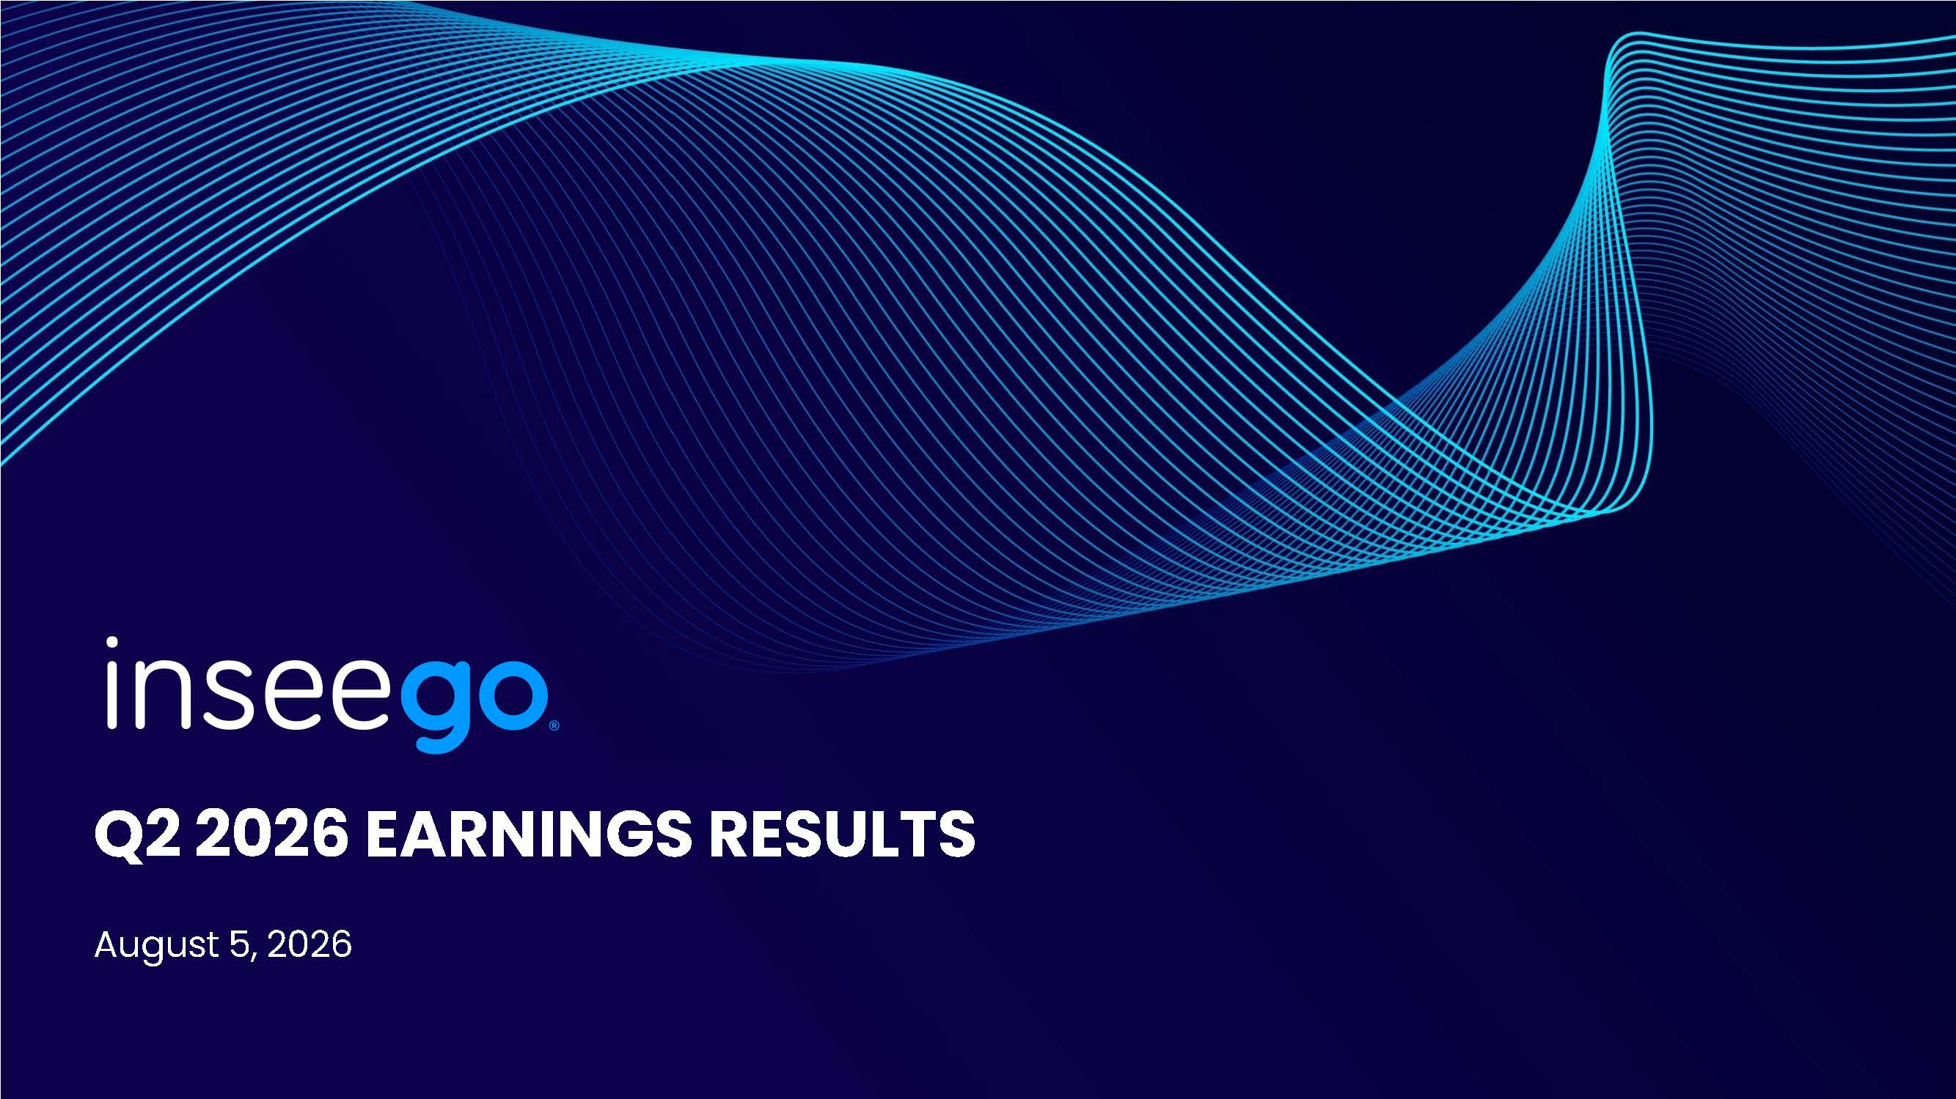
Q2 2026 EARNINGS RESULTS August 5, 2026
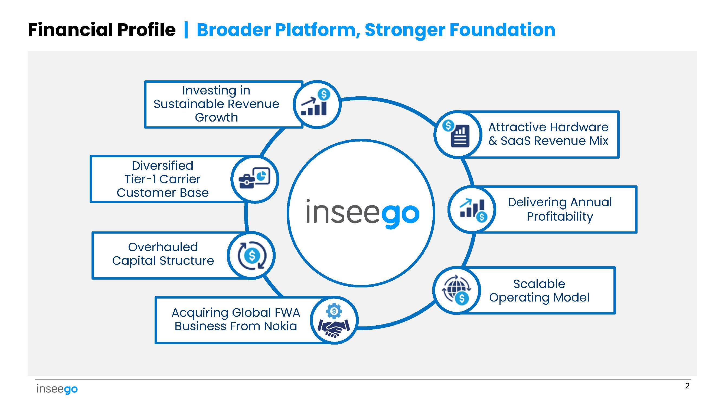
Financial Profile | Broader Platform, Stronger Foundation Overhauled Capital Structure Scalable Operating Model Attractive Hardware & SaaS Revenue Mix Delivering Annual Profitability Diversified Tier - 1 Carrier Customer Base Investing in Sustainable Revenue Growth Acquiring Global FWA Business From Nokia 2
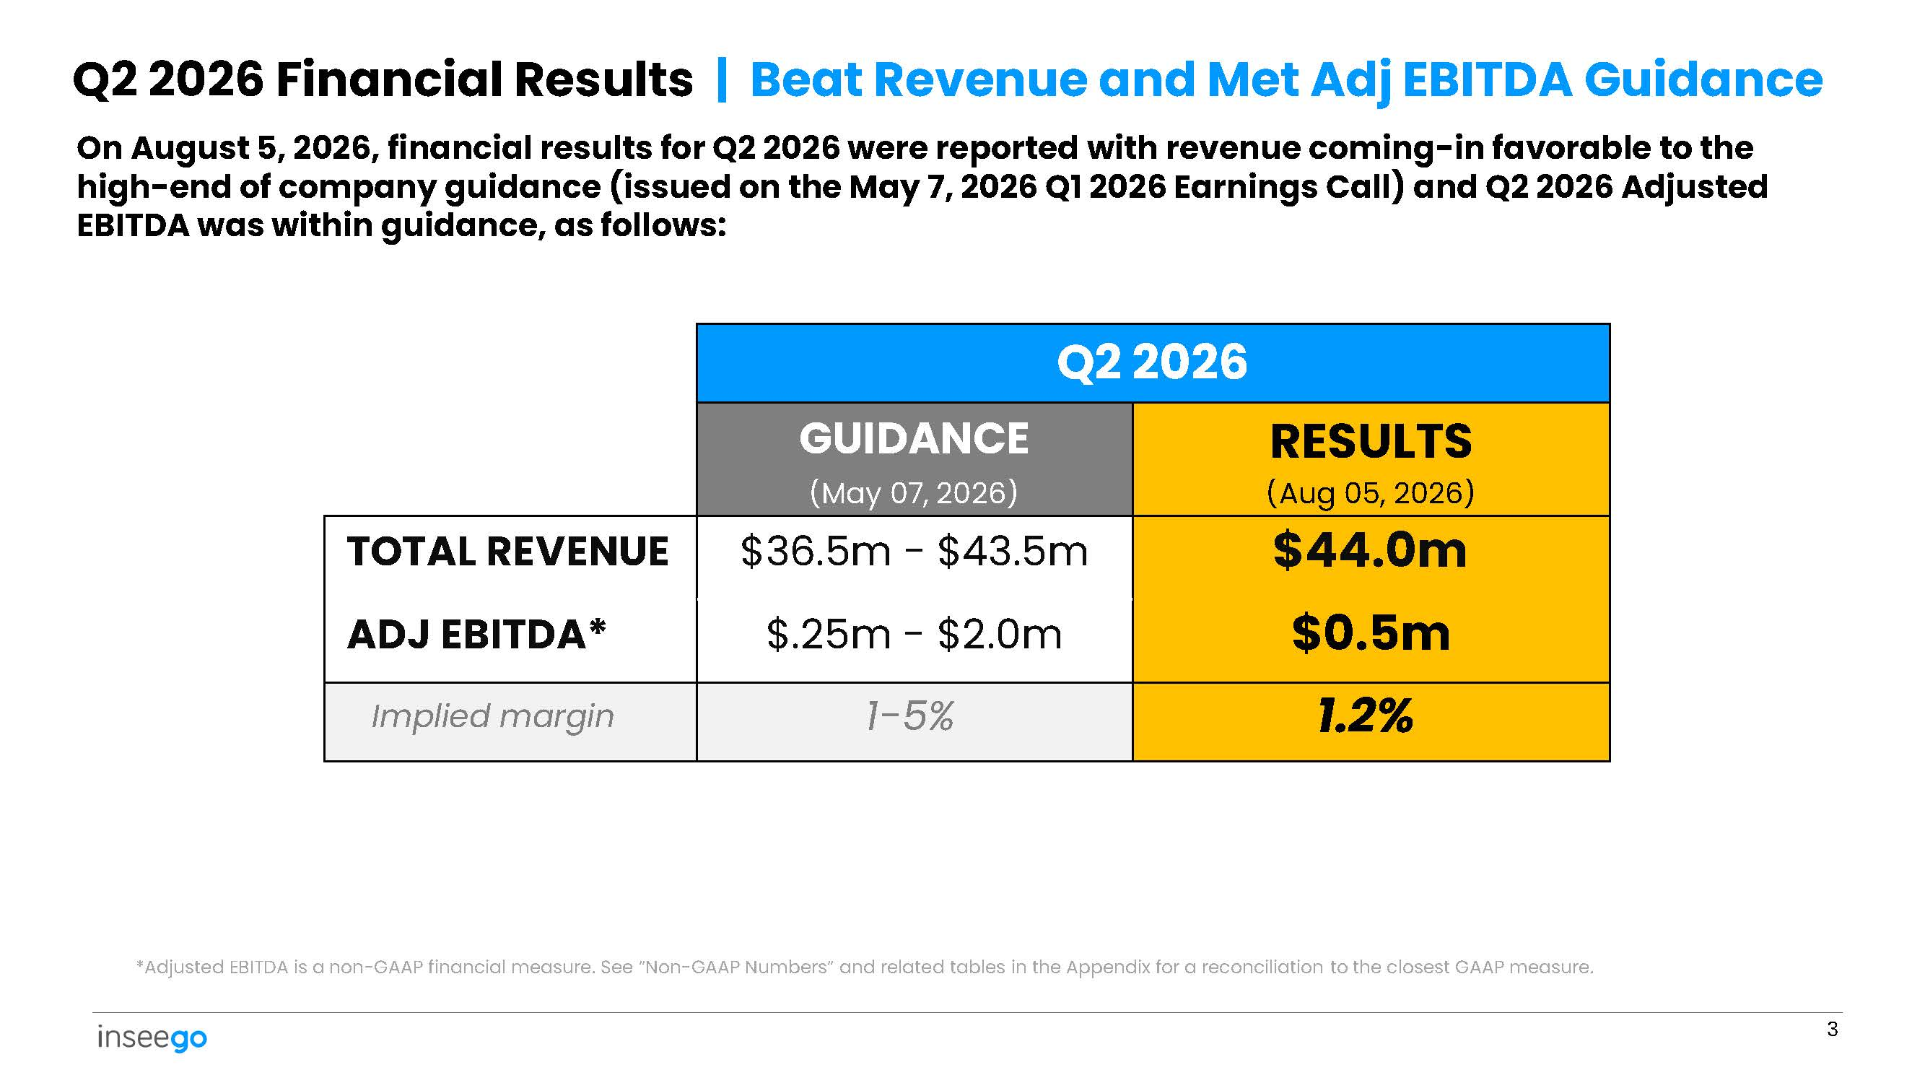
Q2 2026 RESULTS (Aug 05, 2026) GUIDANCE (May 07, 2026) $44.0m $0.5m $36.5m - $43.5m $.25m - $2.0m TOTAL REVENUE ADJ EBITDA* 1.2% 1 - 5% Implied margin 3 Q2 2026 Financial Results | Beat Revenue and Met Adj EBITDA Guidance On August 5, 2026, financial results for Q2 2026 were reported with revenue coming - in favorable to the high - end of company guidance (issued on the May 7, 2026 Q1 2026 Earnings Call) and Q2 2026 Adjusted EBITDA was within guidance, as follows: *Adjusted EBITDA is a non - GAAP financial measure. See ”Non - GAAP Numbers” and related tables in the Appendix for a reconciliation to the closest GAAP measure.
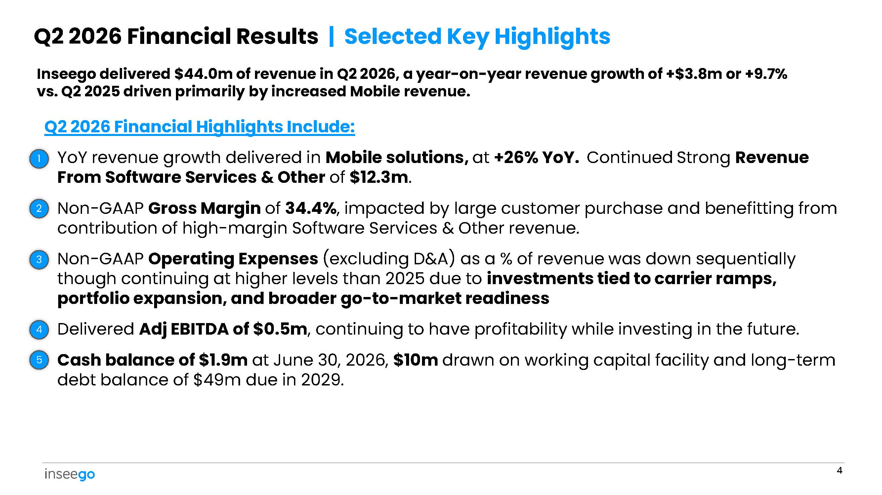
Inseego delivered $44.0m of revenue in Q2 2026, a year - on - year revenue growth of +$3.8m or +9.7% vs. Q2 2025 driven primarily by increased Mobile revenue. Q2 2026 Financial Highlights Include: YoY revenue growth delivered in Mobile solutions, at +26% YoY. Continued Strong Revenue From Software Services & Other of $12.3m . Q2 2026 Financial Results | Selected Key Highlights • 1 2 • Non - GAAP Gross Margin of 34.4% , impacted by large customer purchase and benefitting from contribution of high - margin Software Services & Other revenue. 3 • Non - GAAP Operating Expenses (excluding D&A) as a % of revenue was down sequentially though continuing at higher levels than 2025 due to investments tied to carrier ramps, portfolio expansion, and broader go - to - market readiness 4 • Delivered Adj EBITDA of $0.5m , continuing to have profitability while investing in the future. 5 • Cash balance of $1.9m at June 30, 2026, $10m drawn on working capital facility and long - term debt balance of $49m due in 2029. 4
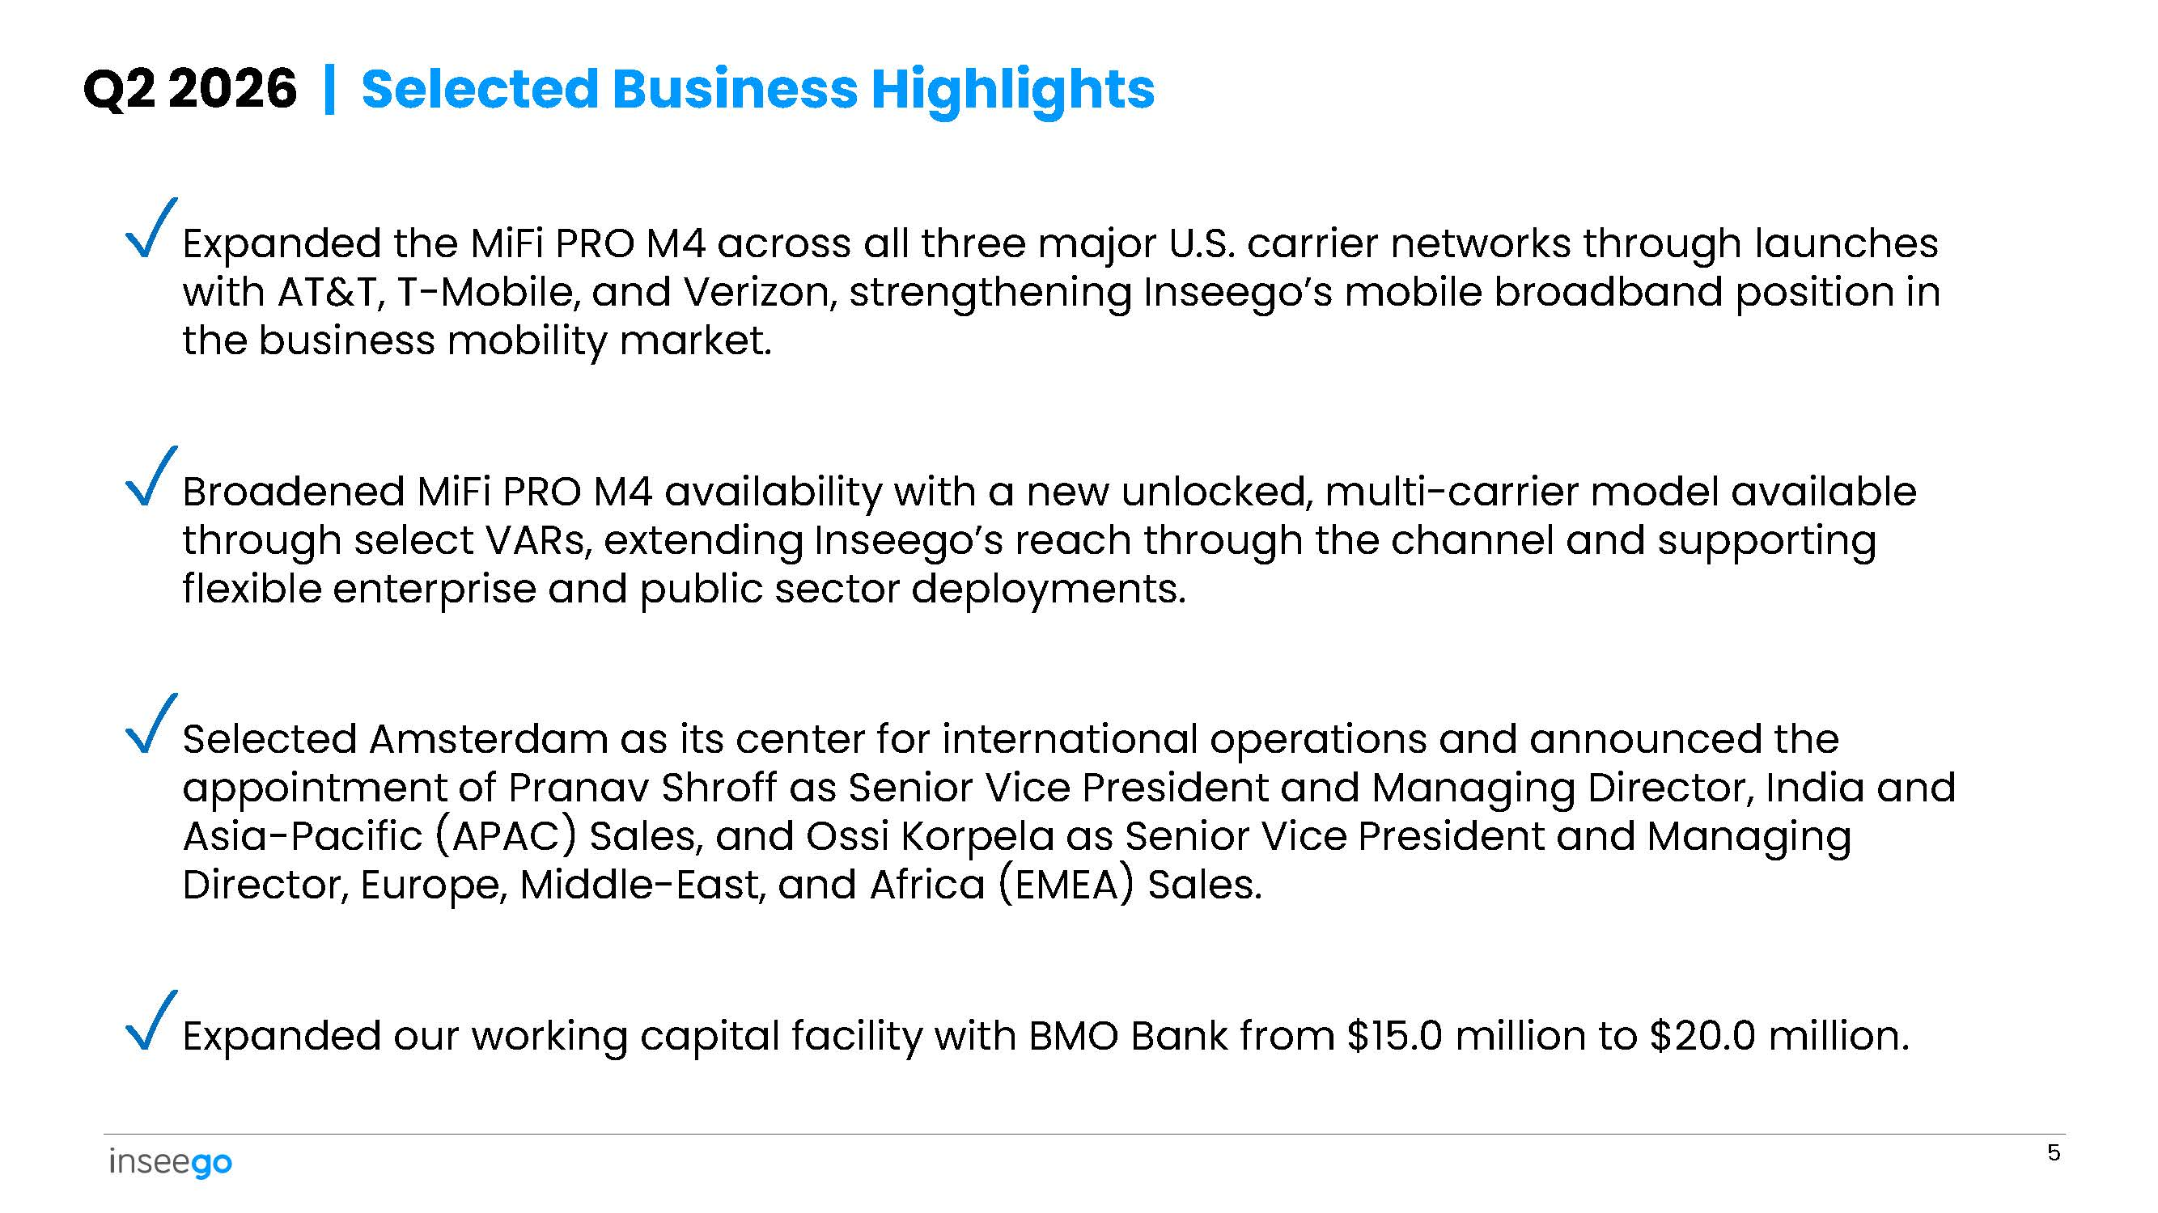
✓ Expanded the MiFi PRO M4 across all three major U.S. carrier networks through launches with AT&T, T - Mobile, and Verizon, strengthening Inseego’s mobile broadband position in the business mobility market. ✓ Broadened MiFi PRO M4 availability with a new unlocked, multi - carrier model available through select VARs, extending Inseego’s reach through the channel and supporting flexible enterprise and public sector deployments. ✓ Selected Amsterdam as its center for international operations and announced the appointment of Pranav Shroff as Senior Vice President and Managing Director, India and Asia - Pacific (APAC) Sales, and Ossi Korpela as Senior Vice President and Managing Director, Europe, Middle - East, and Africa (EMEA) Sales. ✓ Expanded our working capital facility with BMO Bank from $15.0 million to $20.0 million. 5 Q2 2026 | Selected Business Highlights
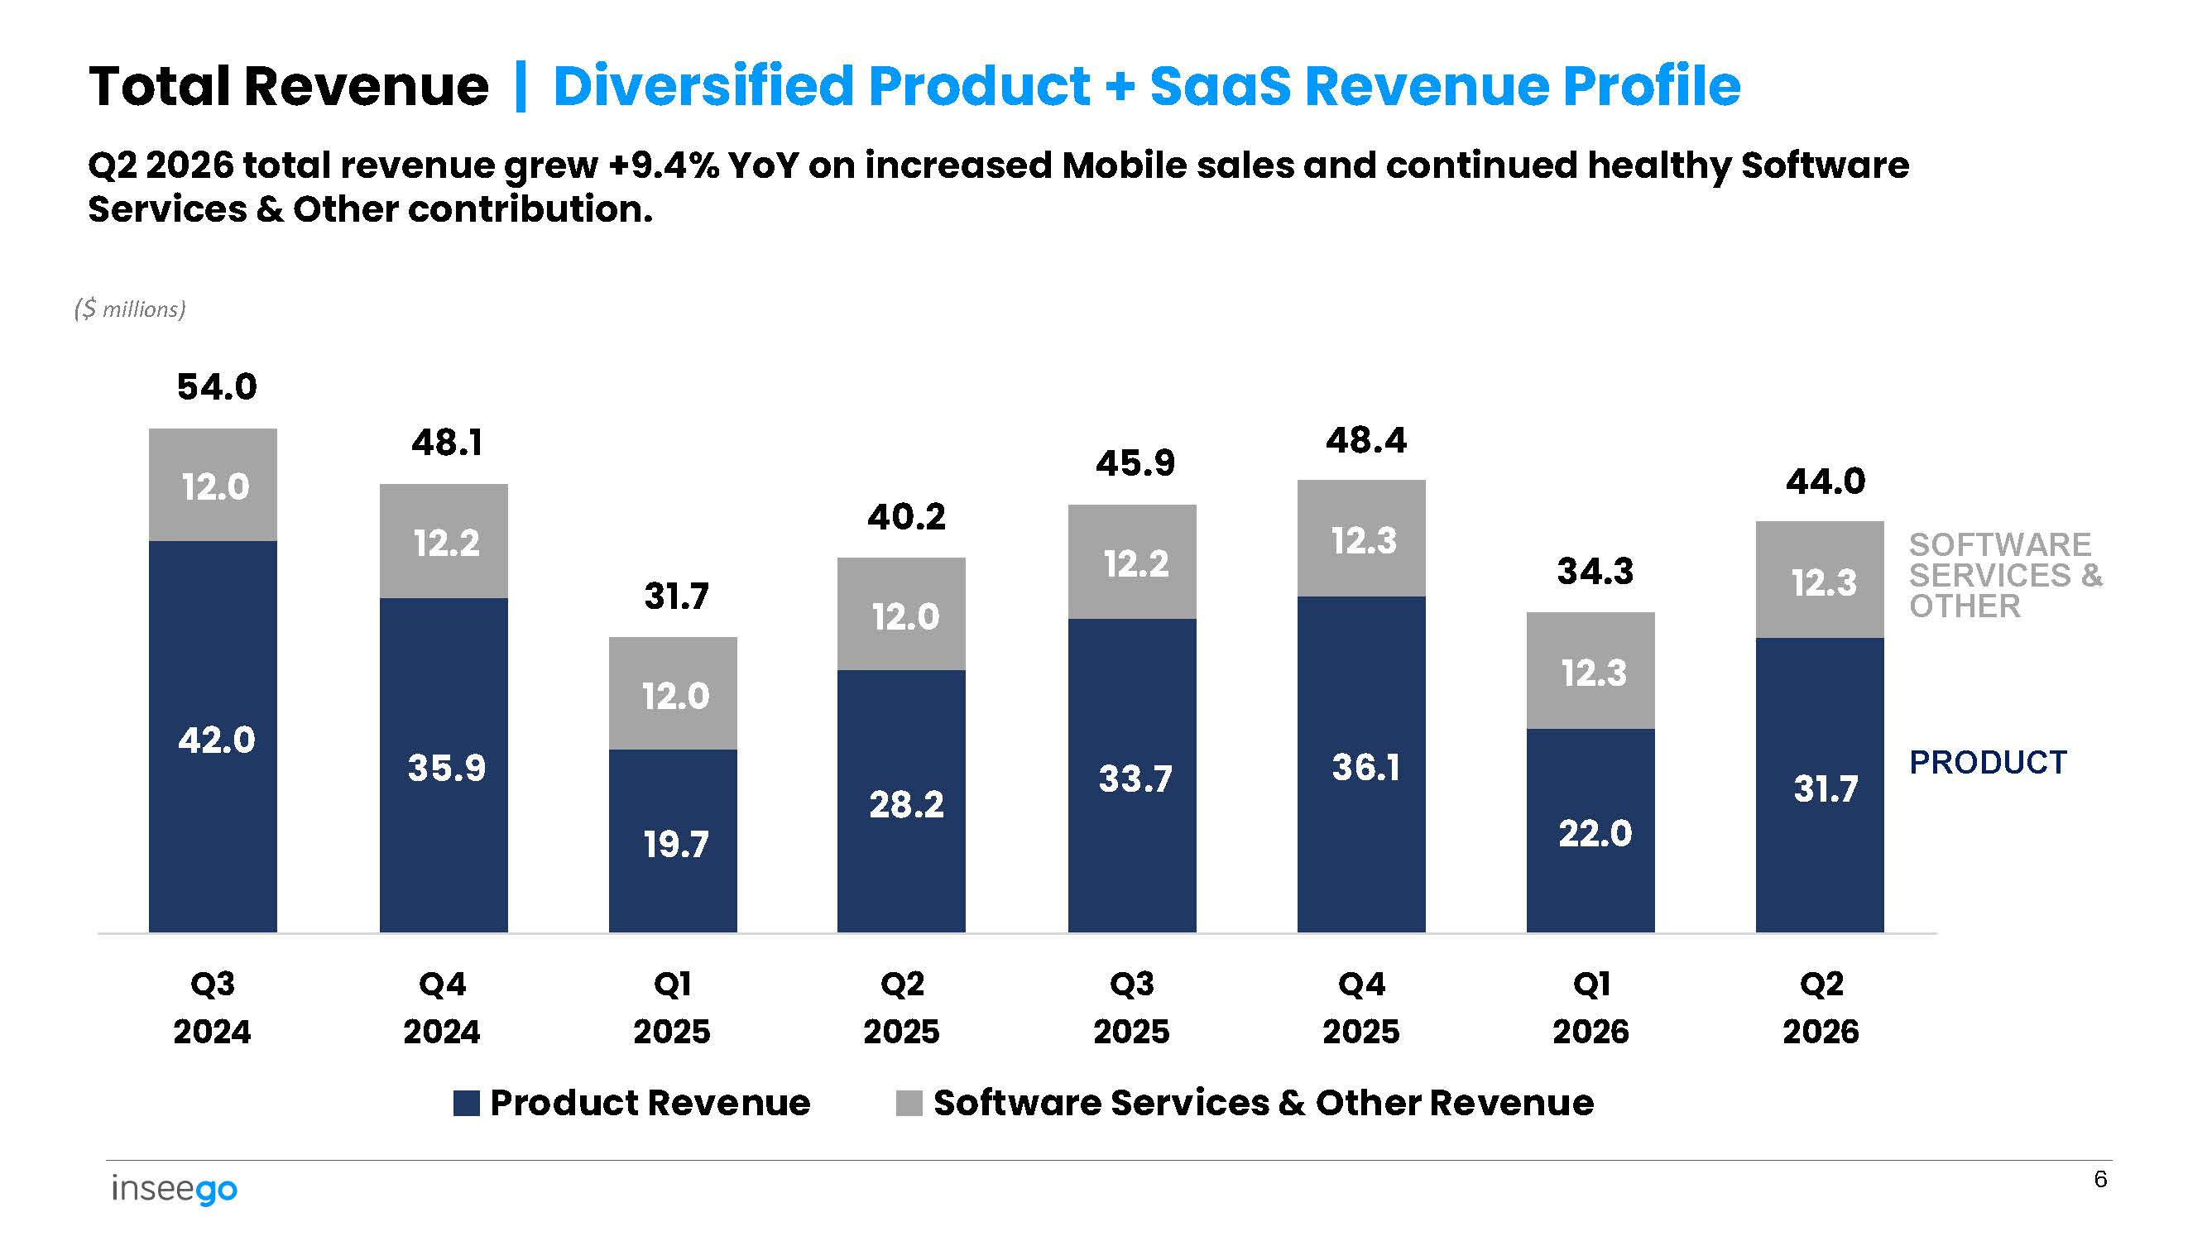
42.0 35.9 19.7 28.2 33.7 36.1 22.0 31.7 12.0 12.2 12.0 12.0 12.2 12.3 12.3 12.3 Q2 2026 total revenue grew +9.4% YoY on increased Mobile sales and continued healthy Software Services & Other contribution. ($ millions) 54.0 48.1 31.7 40.2 45.9 48.4 34.3 44.0 Q3 2024 Q4 2024 Q1 2025 Product Revenue Q2 2025 Q3 2025 Q4 2025 Q1 2026 Q2 2026 Software Services & Other Revenue 6 Total Revenue | Diversified Product + SaaS Revenue Profile PRODUCT SOFTWARE SERVICES & OTHER
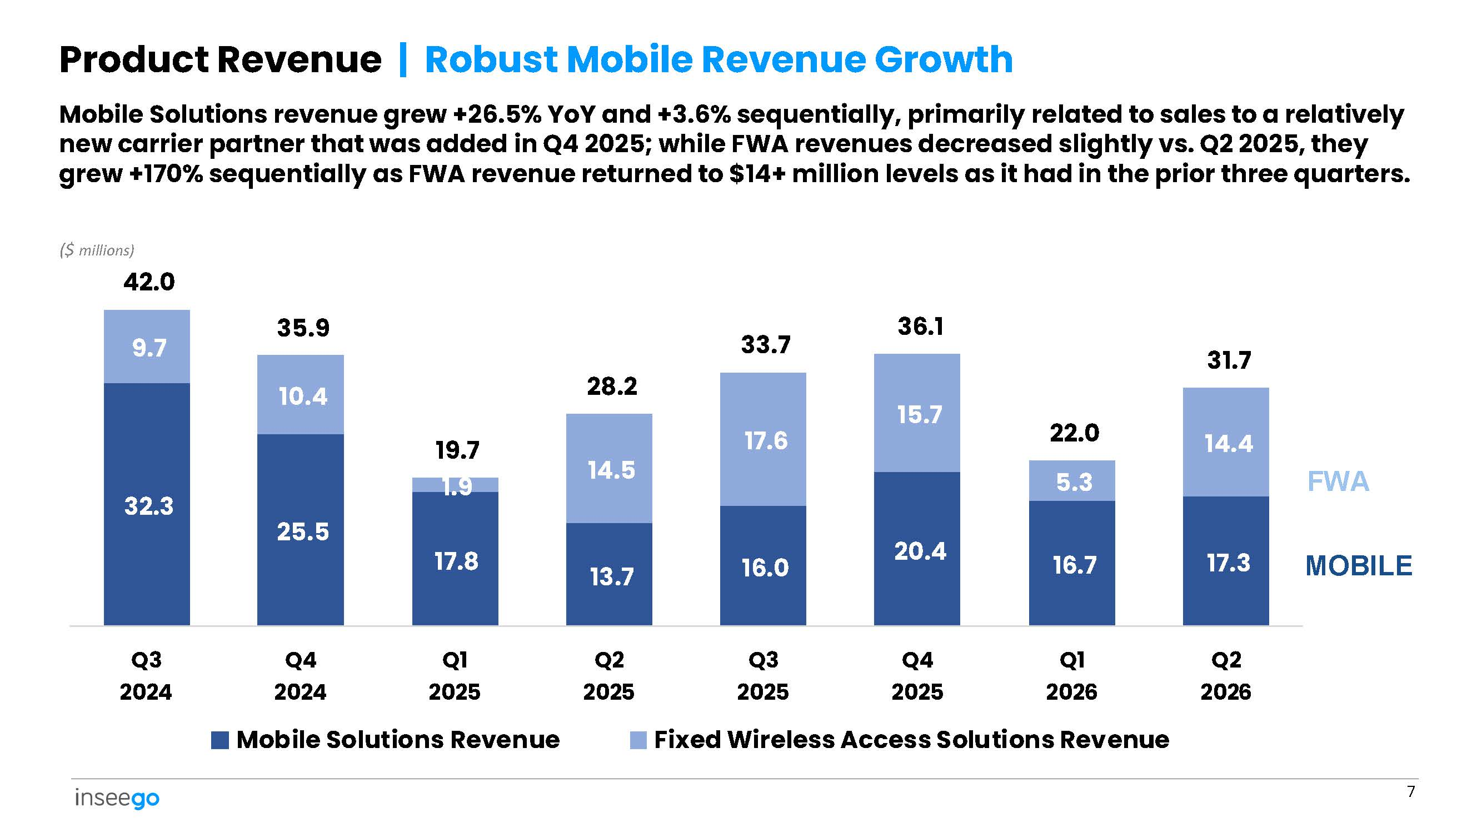
32.3 25.5 17.8 13.7 16.0 20.4 16.7 17.3 9.7 10.4 14.5 17.6 15.7 5.3 14.4 Mobile Solutions revenue grew +26.5% YoY and +3.6% sequentially, primarily related to sales to a relatively new carrier partner that was added in Q4 2025; while FWA revenues decreased slightly vs. Q2 2025, they grew +170% sequentially as FWA revenue returned to $14+ million levels as it had in the prior three quarters. ($ millions) 42.0 35.9 19.7 1.9 28.2 33.7 36.1 22.0 31.7 Q3 2024 Q4 2024 Q1 2025 Q2 2025 Q3 2025 Q4 2025 Q1 2026 Q2 2026 Mobile Solutions Revenue Fixed Wireless Access Solutions Revenue 7 Product Revenue | Robust Mobile Revenue Growth MOBILE FWA
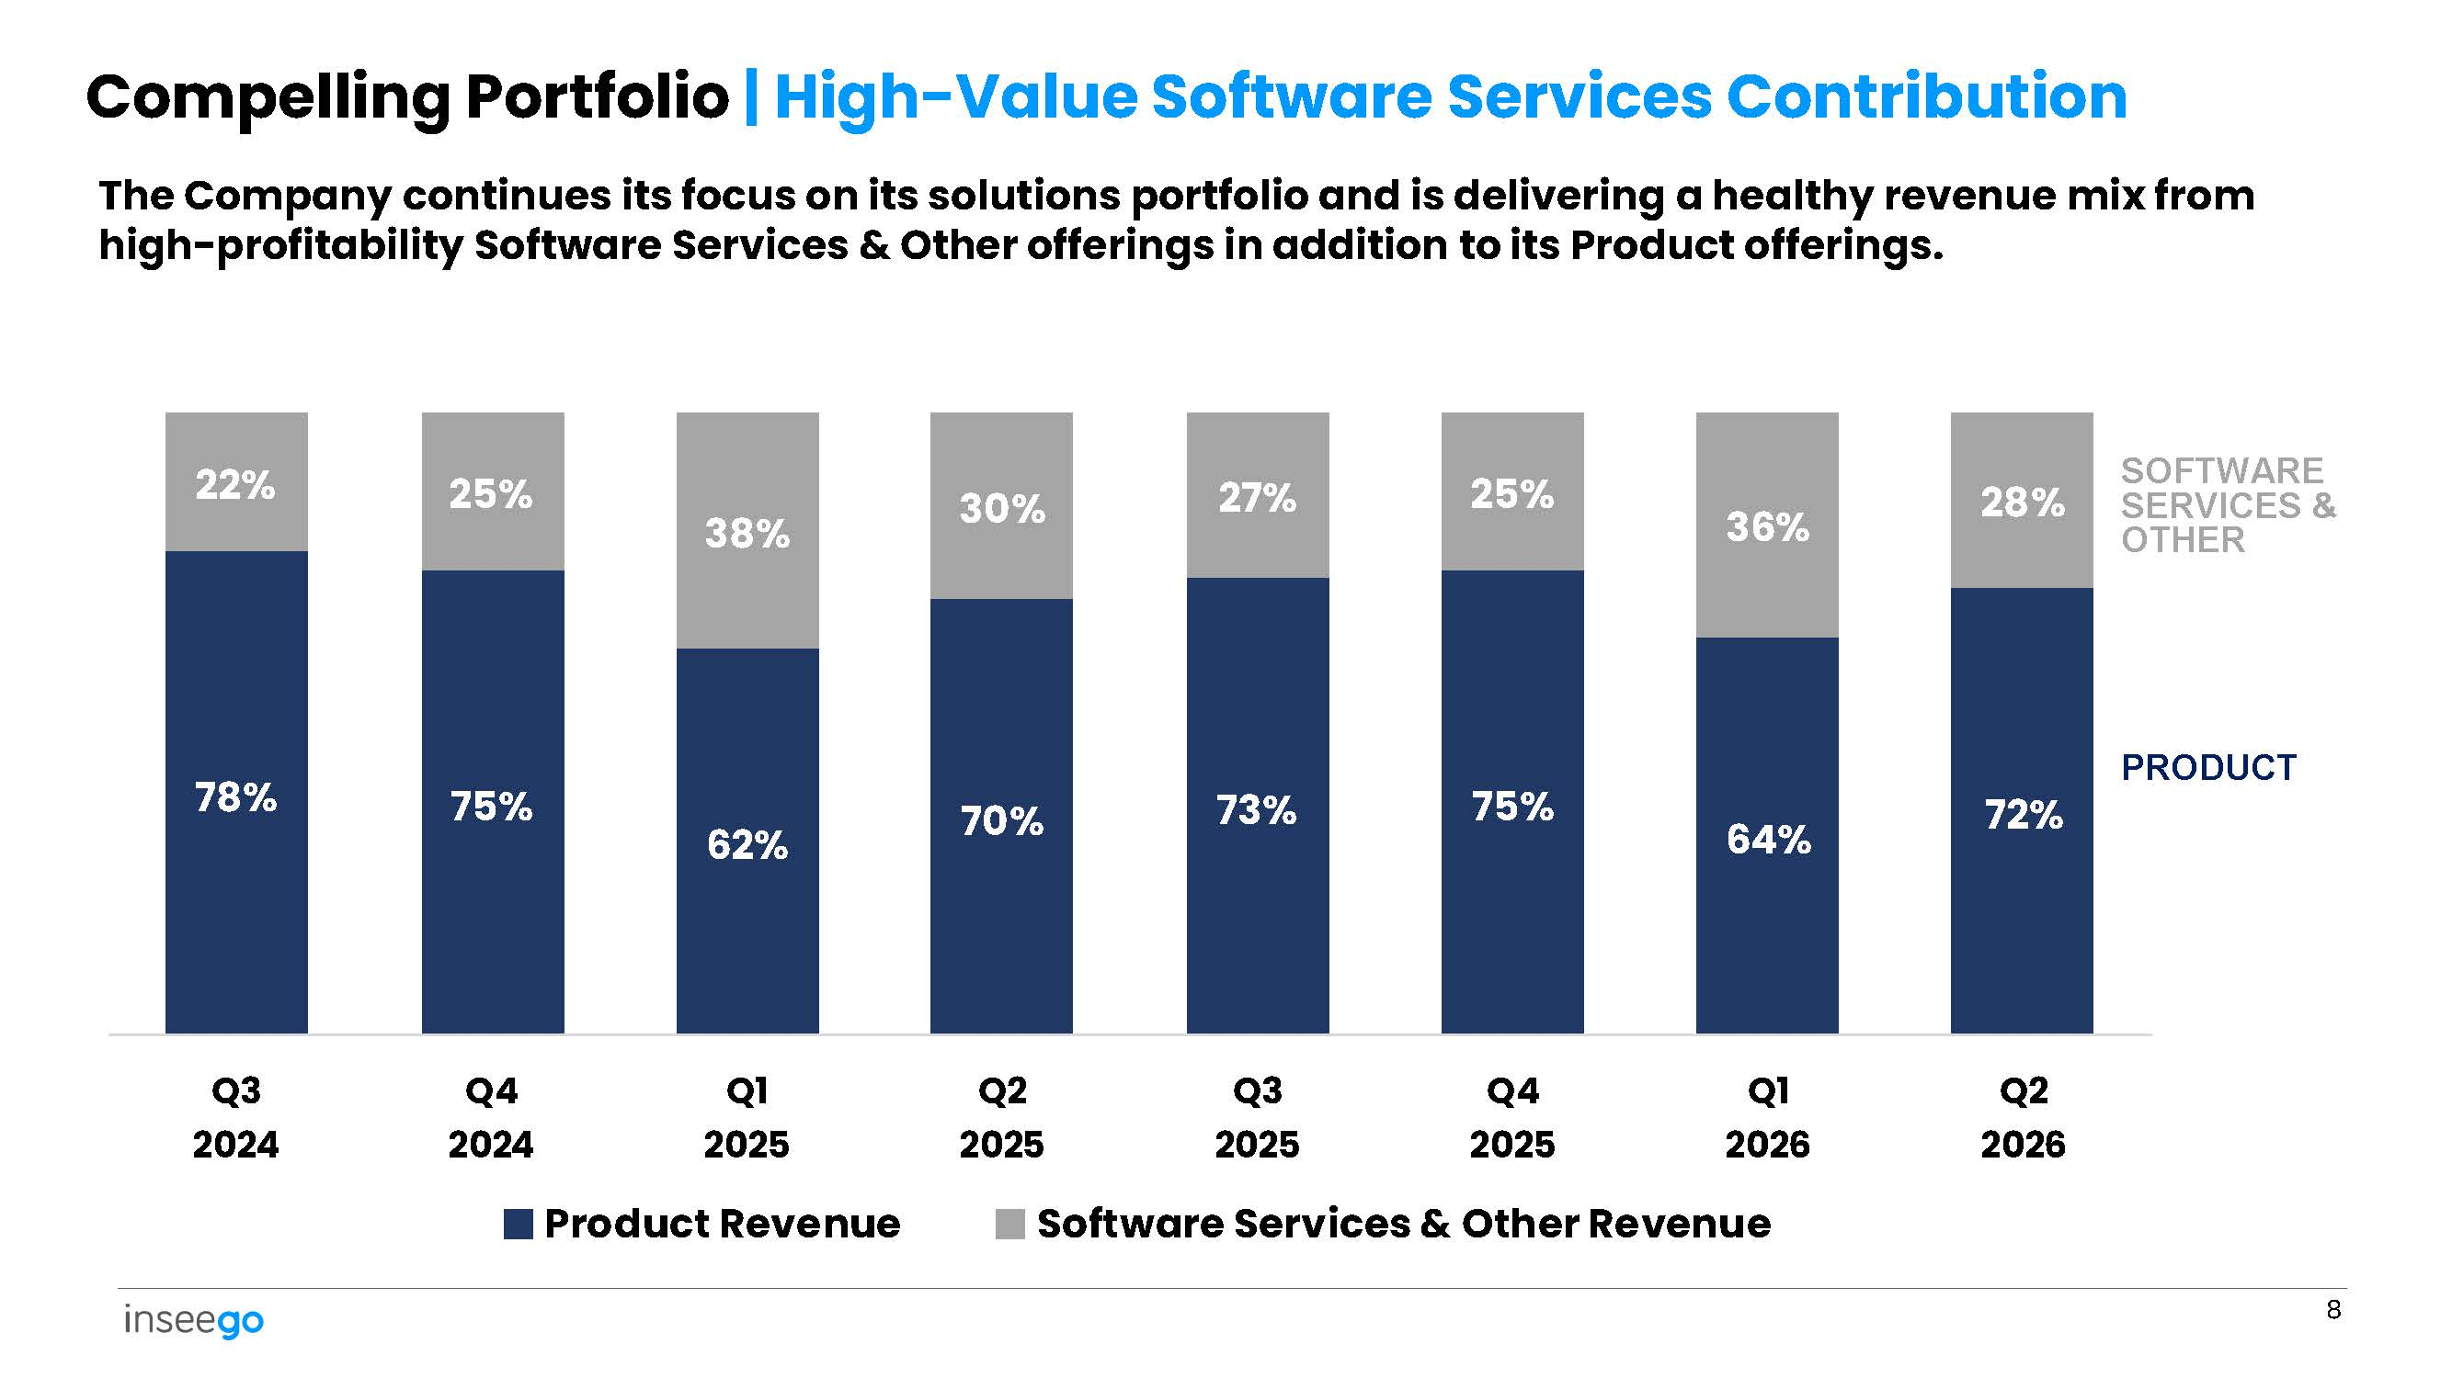
78% 75% 62% 70% 73% 75% 64% 72% 22% 25% 38% 30% 27% 25% 36% 28% Q2 Q1 Q4 Q3 Q2 Q1 Q4 Q3 2026 2026 2025 2025 2025 2025 2024 2024 Product Revenue Software Services & Other Revenue 8 Compelling Portfolio | High - Value Software Services Contribution The Company continues its focus on its solutions portfolio and is delivering a healthy revenue mix from high - profitability Software Services & Other offerings in addition to its Product offerings. PRODUCT SOFTWARE SERVICES & OTHER
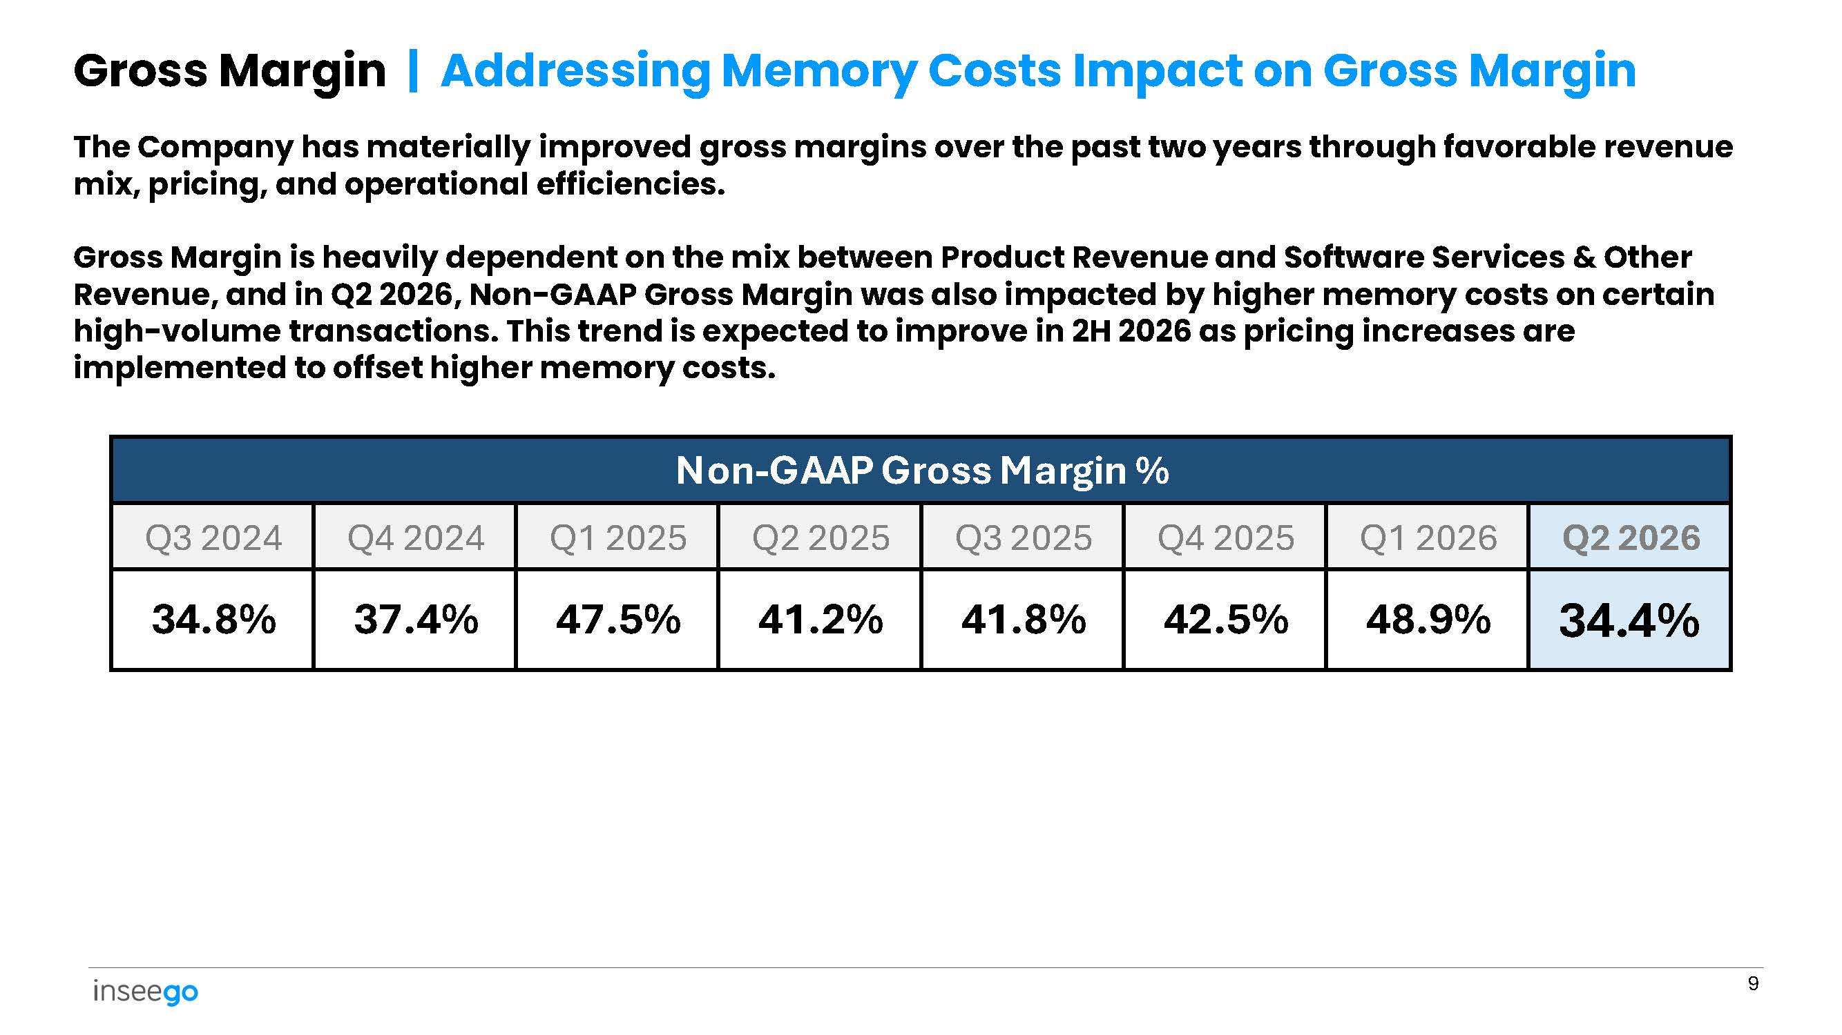
Gross Margin | Addressing Memory Costs Impact on Gross Margin 9 The Company has materially improved gross margins over the past two years through favorable revenue mix, pricing, and operational efficiencies. Gross Margin is heavily dependent on the mix between Product Revenue and Software Services & Other Revenue, and in Q2 2026, Non - GAAP Gross Margin was also impacted by higher memory costs on certain high - volume transactions. This trend is expected to improve in 2H 2026 as pricing increases are implemented to offset higher memory costs. Non - GAAP Gross Margin % Q2 2026 Q1 2026 Q4 2025 Q3 2025 Q2 2025 Q1 2025 Q4 2024 Q3 2024 34.4% 48.9% 42.5% 41.8% 41.2% 47.5% 37.4% 34.8%
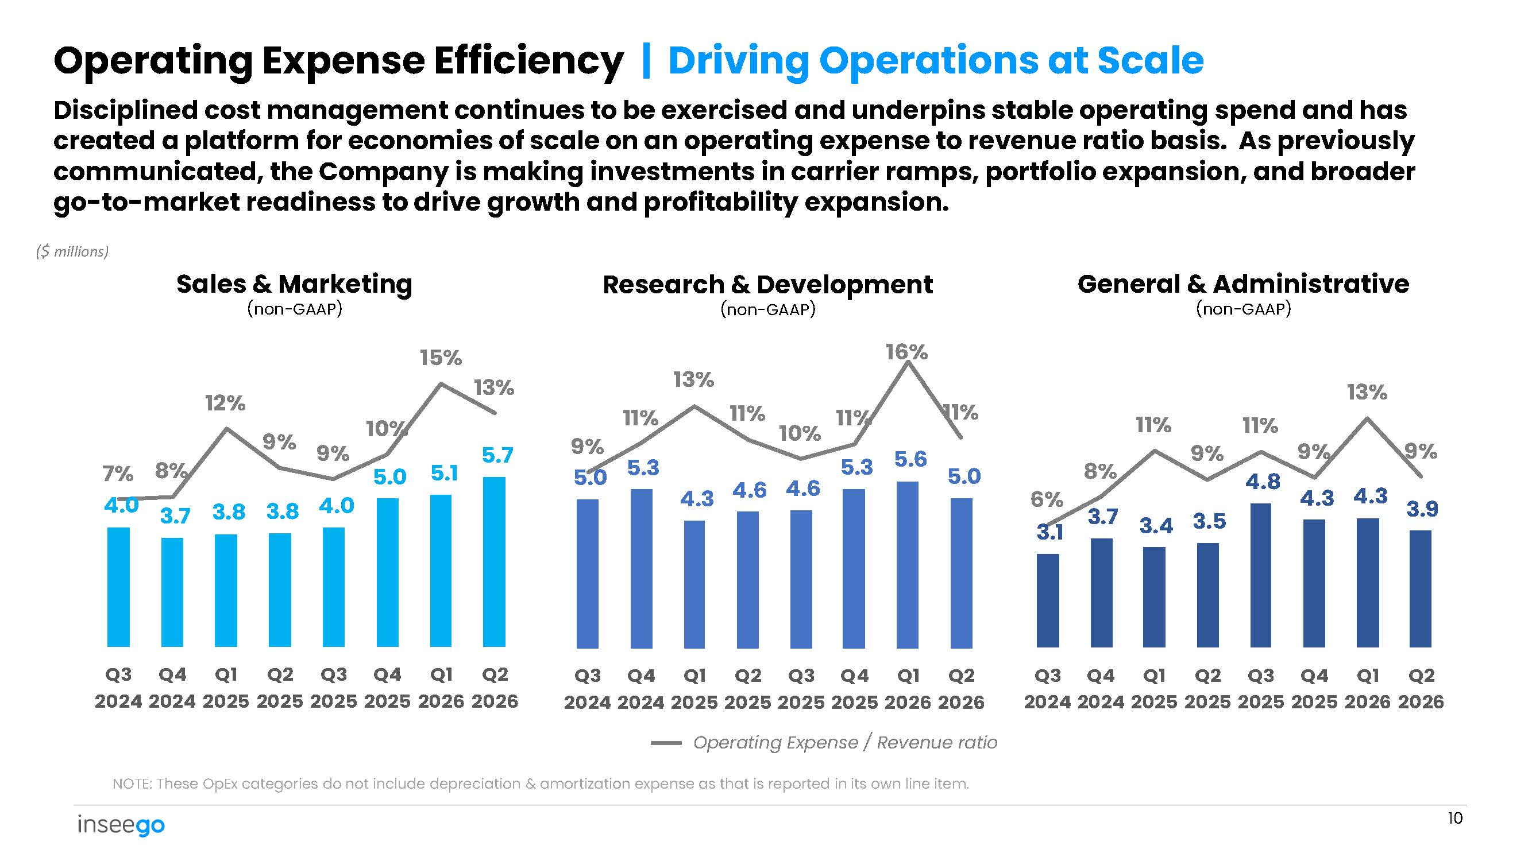
3.4 3.5 4.8 4.3 3.9 6% 3.1 8% 3.7 11% 9% 11% 9% 4.3 13% 9% 4.3 4.6 4.6 5.3 5.6 5.0 9% 5.0 11% 5.3 13% 11% 10% 11% 16% 11% Operating Expense Efficiency | Driving Operations at Scale Disciplined cost management continues to be exercised and underpins stable operating spend and has created a platform for economies of scale on an operating expense to revenue ratio basis . As previously communicated, the Company is making investments in carrier ramps, portfolio expansion, and broader go - to - market readiness to drive growth and profitability expansion . ($ millions) Sales & Marketing (non - GAAP) Research & Development (non - GAAP) General & Administrative (non - GAAP) Q3 Q4 Q1 Q2 Q3 Q4 Q1 Q2 Q3 Q4 Q1 Q2 Q3 Q4 Q1 Q2 2024 2024 2025 2025 2025 2025 2026 2026 2024 2024 2025 2025 2025 2025 2026 2026 Operating Expense / Revenue ratio NOTE: These OpEx categories do not include depreciation & amortization expense as that is reported in its own line item. 3.8 3.8 10 5.1 5.7 7% 4.0 8% 3.7 12% 9% 9% 4.0 10% 5.0 15% 13% Q3 Q4 Q1 Q2 Q3 Q4 Q1 Q2 2024 2024 2025 2025 2025 2025 2026 2026
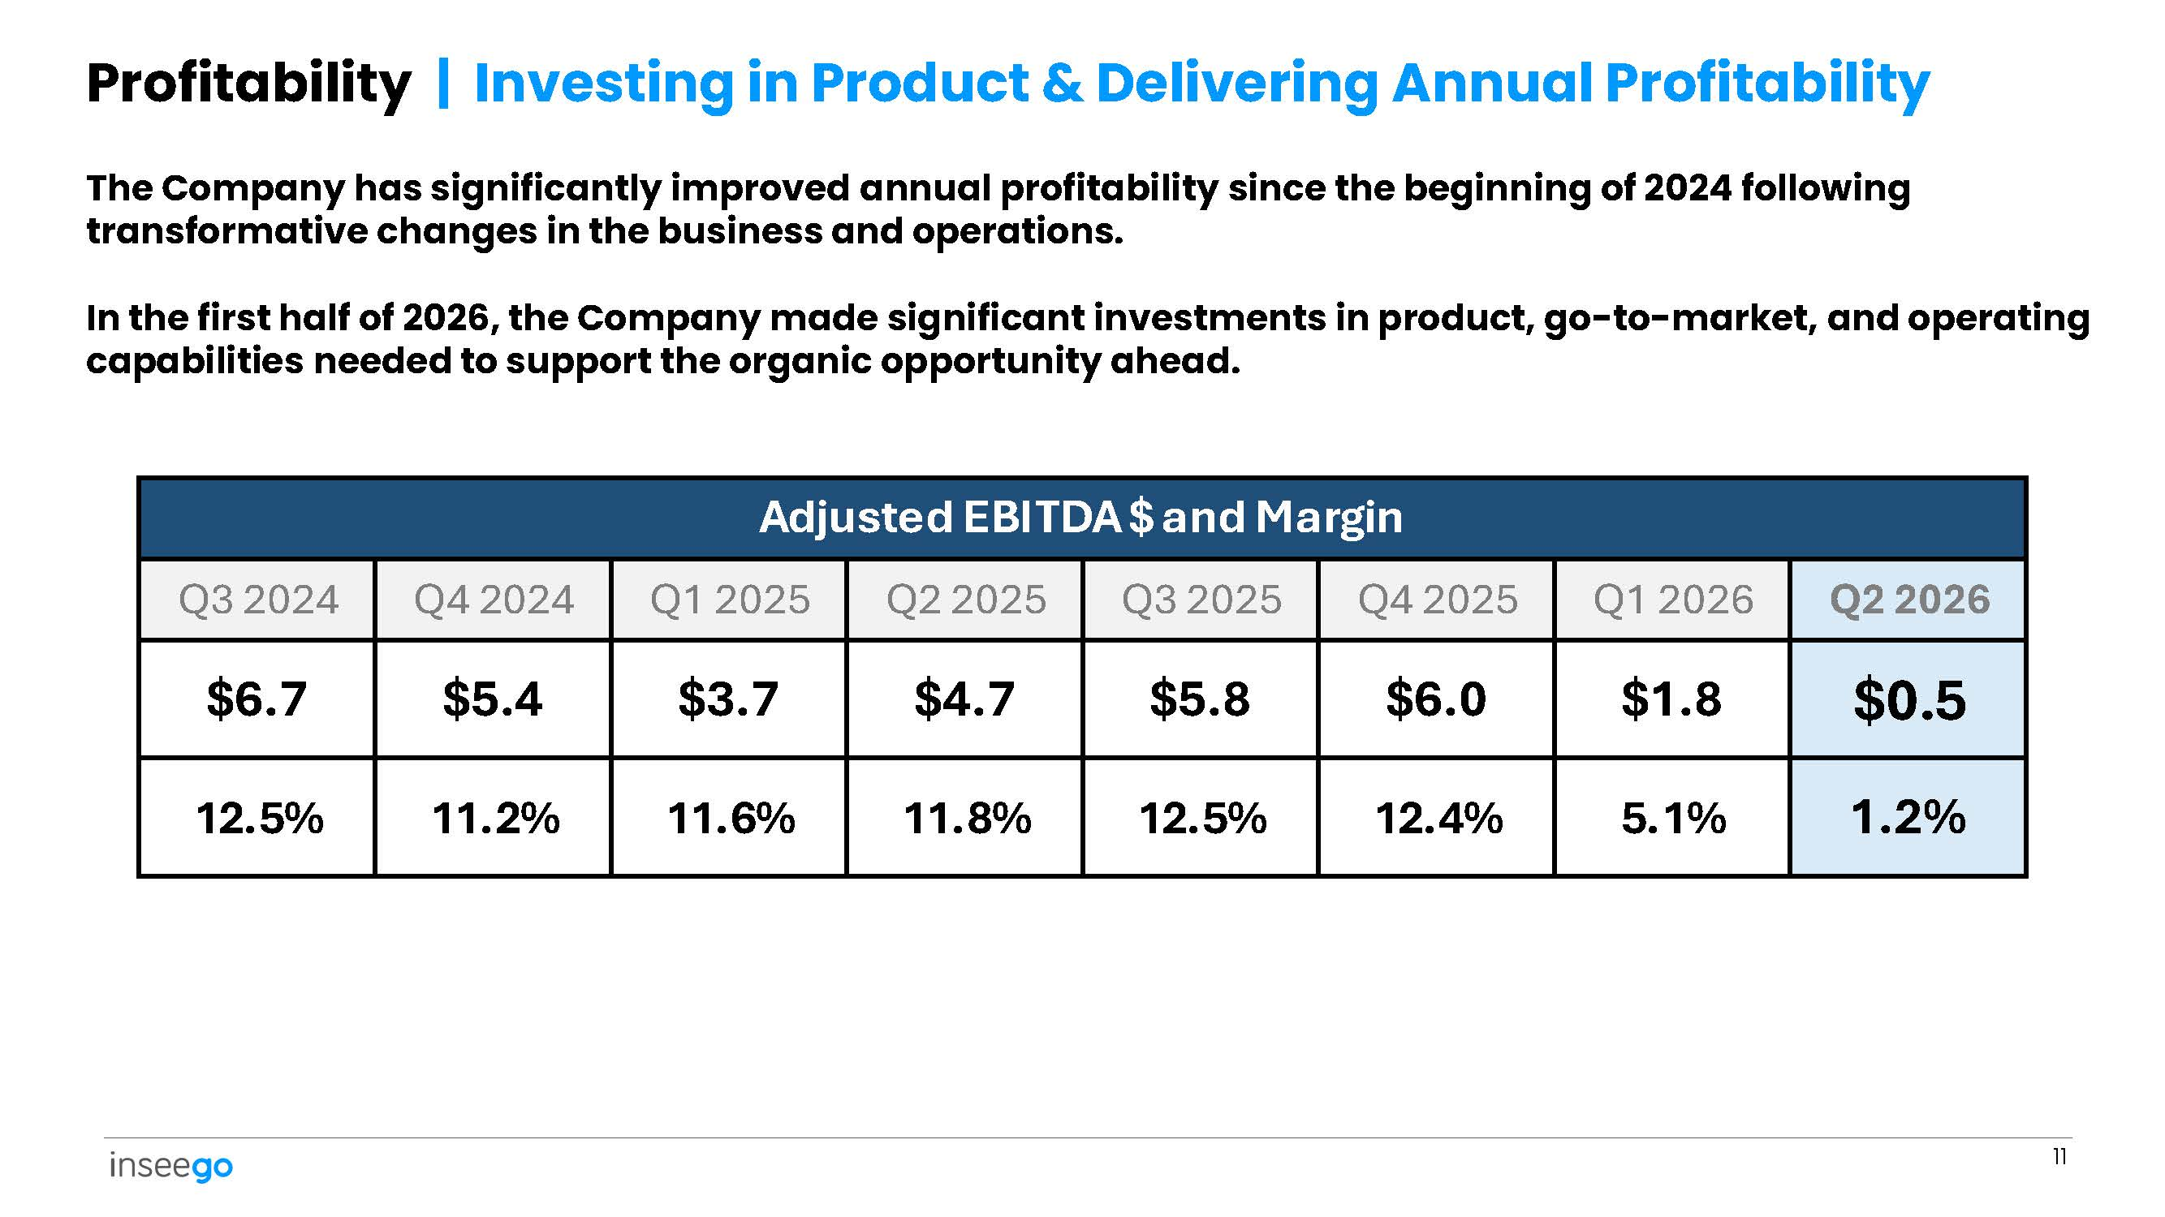
Profitability | Investing in Product & Delivering Annual Profitability 11 The Company has significantly improved annual profitability since the beginning of 2024 following transformative changes in the business and operations. In the first half of 2026, the Company made significant investments in product, go - to - market, and operating capabilities needed to support the organic opportunity ahead. Adjusted EBITDA $ and Margin Q2 2026 Q1 2026 Q4 2025 Q3 2025 Q2 2025 Q1 2025 Q4 2024 Q3 2024 $0.5 $1.8 $6.0 $5.8 $4.7 $3.7 $5.4 $6.7 1.2% 5.1% 12.4% 12.5% 11.8% 11.6% 11.2% 12.5%
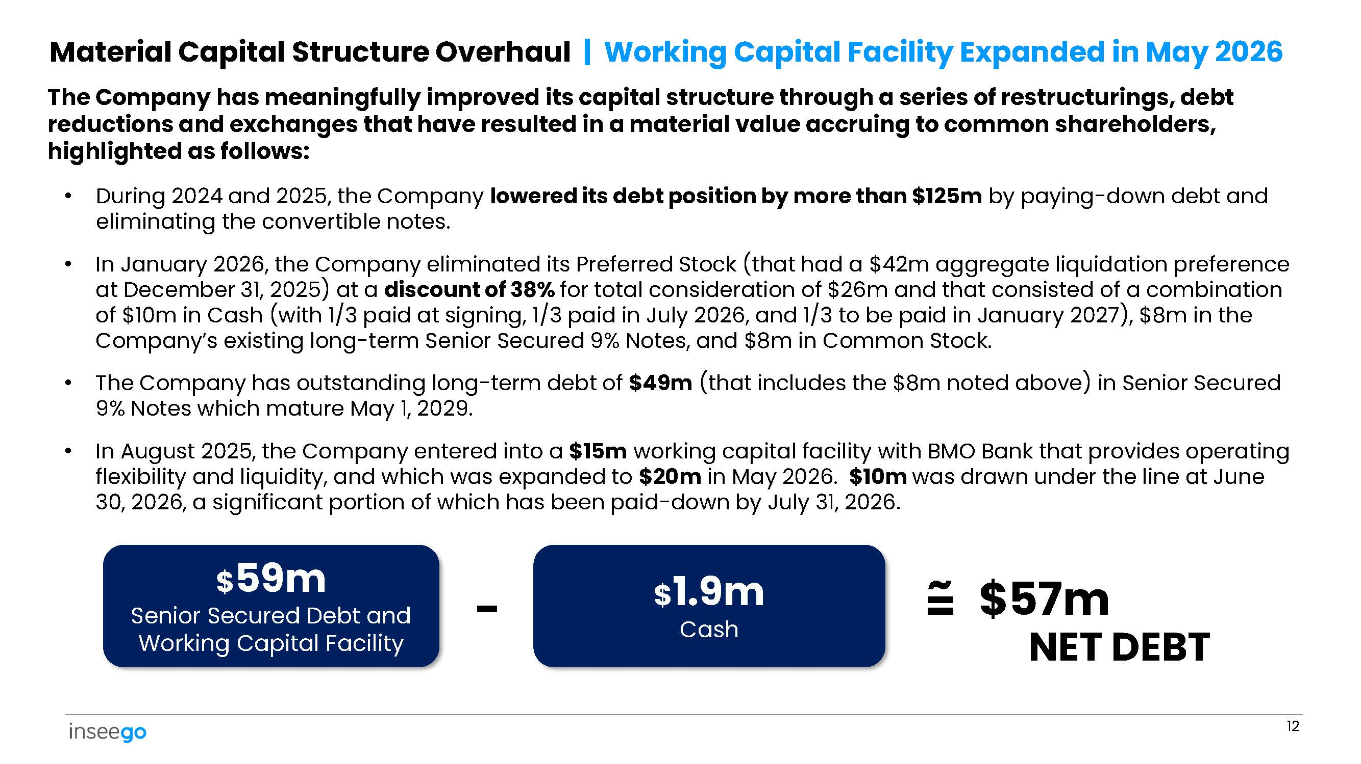
Material Capital Structure Overhaul | Working Capital Facility Expanded in May 2026 The Company has meaningfully improved its capital structure through a series of restructurings, debt reductions and exchanges that have resulted in a material value accruing to common shareholders, highlighted as follows: • During 2024 and 2025, the Company lowered its debt position by more than $125m by paying - down debt and eliminating the convertible notes. • In January 2026, the Company eliminated its Preferred Stock (that had a $42m aggregate liquidation preference at December 31, 2025) at a discount of 38% for total consideration of $26m and that consisted of a combination of $10m in Cash (with 1/3 paid at signing, 1/3 paid in July 2026, and 1/3 to be paid in January 2027), $8m in the Company’s existing long - term Senior Secured 9% Notes, and $8m in Common Stock. • The Company has outstanding long - term debt of $49m (that includes the $8m noted above) in Senior Secured 9% Notes which mature May 1, 2029. • In August 2025, the Company entered into a $15m working capital facility with BMO Bank that provides operating flexibility and liquidity, and which was expanded to $20m in May 2026. $10m was drawn under the line at June 30, 2026, a significant portion of which has been paid - down by July 31, 2026. $ 59m Senior Secured Debt and Working Capital Facility $ 1.9m Cash 12 - NET DEBT = ~ $57m
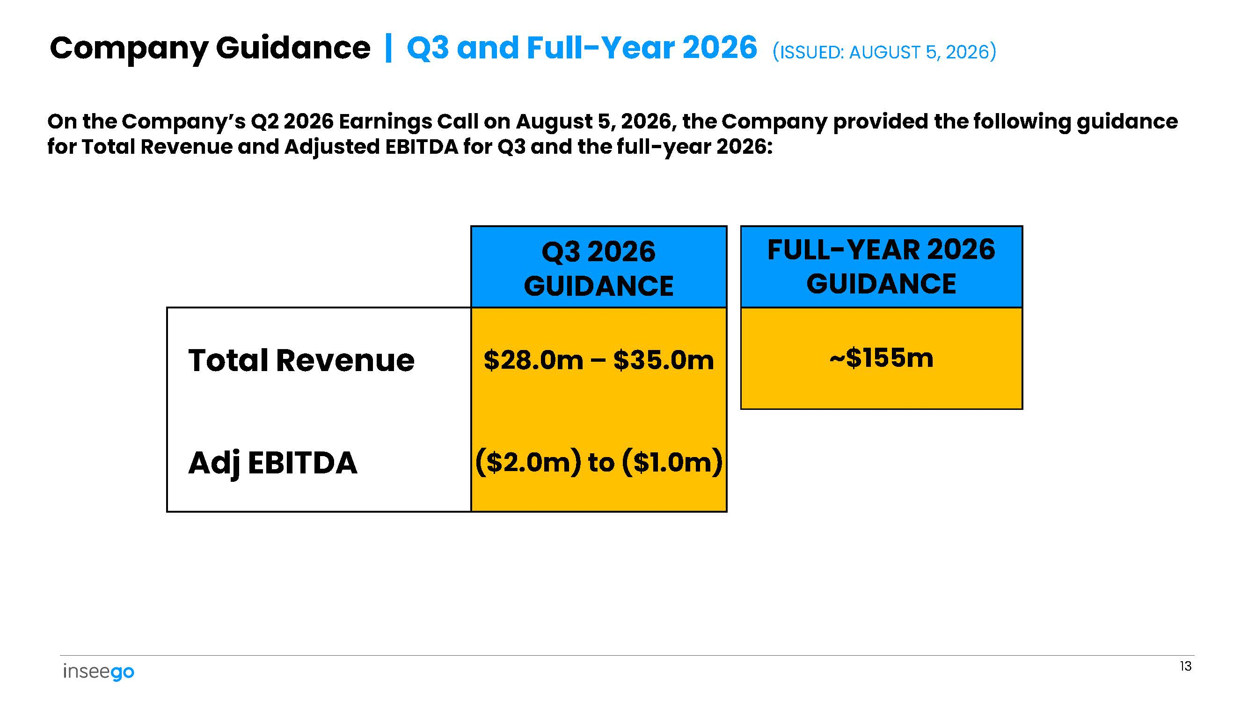
FULL - YEAR 2026 GUIDANCE Q3 2026 GUIDANCE ~$155m $28.0m – $35.0m Total Revenue ($2.0m) to ($1.0m) Adj EBITDA 13 On the Company’s Q2 2026 Earnings Call on August 5, 2026, the Company provided the following guidance for Total Revenue and Adjusted EBITDA for Q3 and the full - year 2026: Company Guidance | Q3 and Full - Year 2026 (ISSUED: AUGUST 5, 2026)
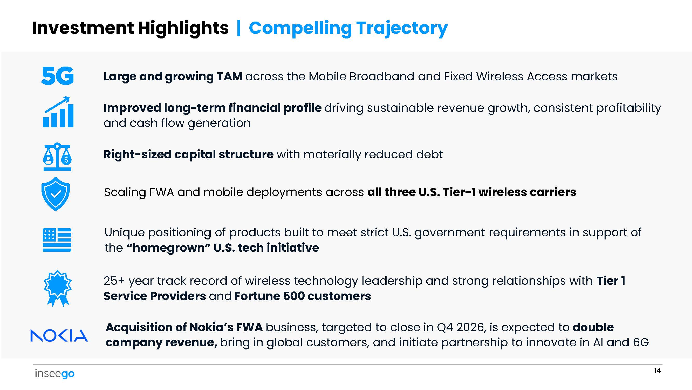
Investment Highlights | Compelling Trajectory Large and growing TAM across the Mobile Broadband and Fixed Wireless Access markets Improved long - term financial profile driving sustainable revenue growth, consistent profitability and cash flow generation Right - sized capital structure with materially reduced debt Scaling FWA and mobile deployments across all three U.S. Tier - 1 wireless carriers Unique positioning of products built to meet strict U.S. government requirements in support of the “homegrown” U.S. tech initiative 25+ year track record of wireless technology leadership and strong relationships with Tier 1 Service Providers and Fortune 500 customers Acquisition of Nokia’s FWA business, targeted to close in Q4 2026, is expected to double company revenue, bring in global customers, and initiate partnership to innovate in AI and 6G 14
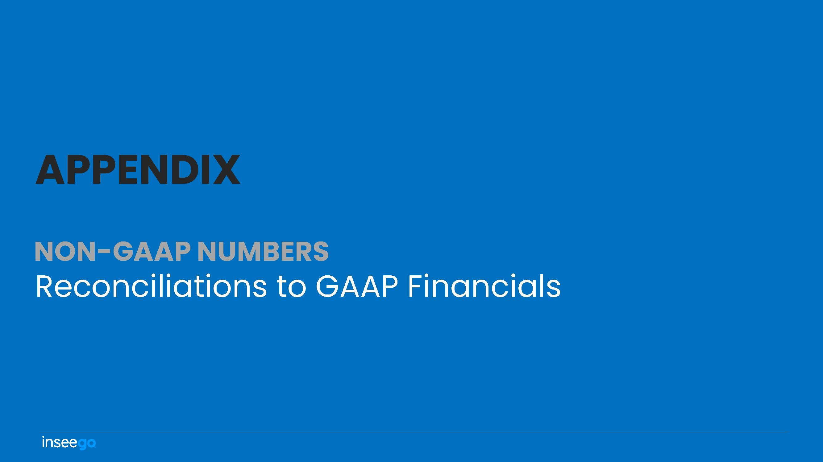
NON - GAAP NUMBERS Reconciliations to GAAP Financials APPENDIX
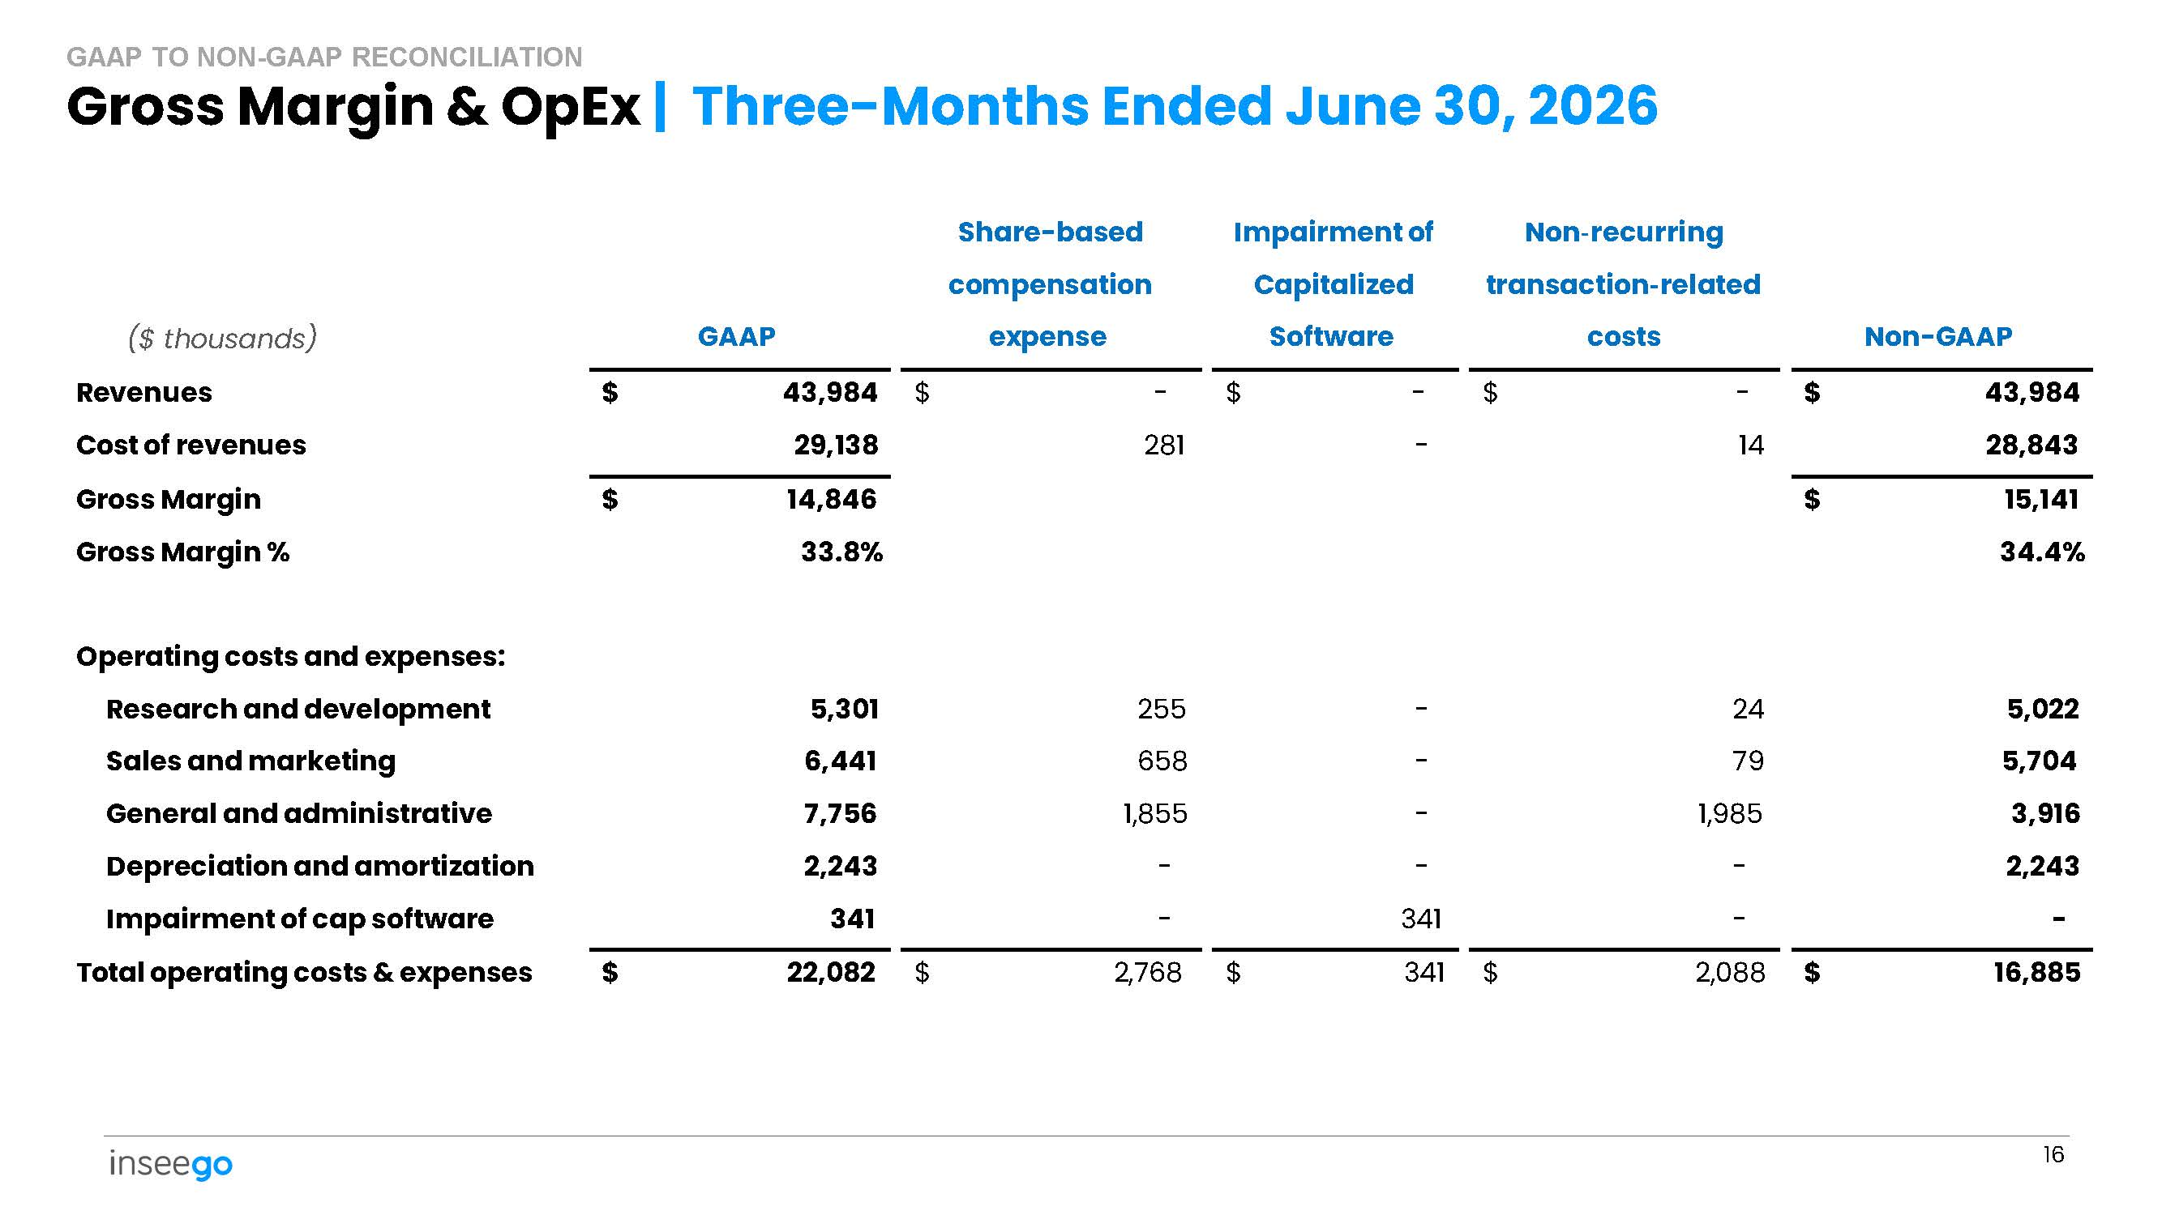
($ thousands) 16 GAAP Share - based compensation expense Impairment of Capitalized Software Non - recurring transaction - related costs Non - GAAP $ 43,984 - $ - $ - $ $ 43,984 Revenues 28,843 14 - 281 29,138 Cost of revenues $ 15,141 $ 14,846 Gross Margin 34.4% 33.8% Gross Margin % 5,022 24 - 255 5,301 Operating costs and expenses: Research and development 5,704 79 - 658 6,441 Sales and marketing 3,916 1,985 - 1,855 7,756 General and administrative 2,243 - - - 2,243 Depreciation and amortization - - 341 - 341 Impairment of cap software $ 16,885 2,088 $ 341 $ 2,768 $ $ 22,082 Total operating costs & expenses Gross Margin & OpEx | Three - Months Ended June 30, 2026 GAAP TO NON - GAAP RECONCILIATION
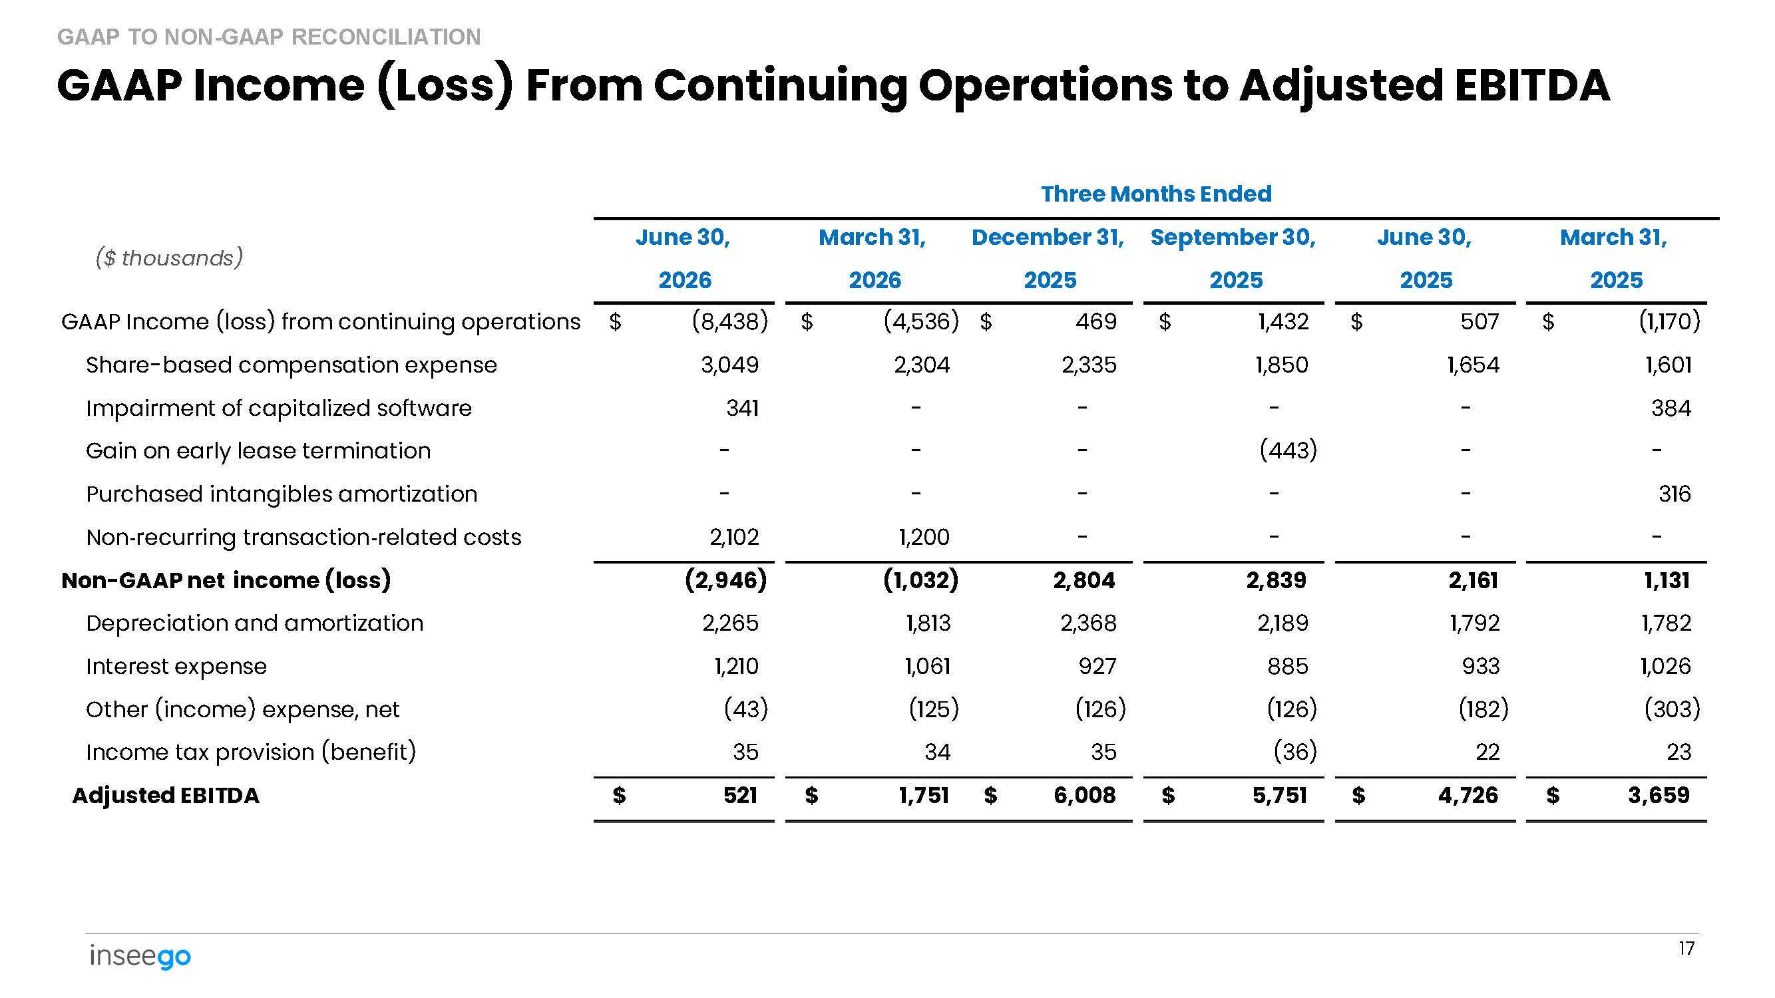
March 31, 2025 June 30, 2025 September 30, 2025 December 31, 2025 March 31, 2026 June 30, 2026 ($ thousands) $ (1,170) $ 507 $ 1,432 $ 469 $ (4,536) $ (8,438) GAAP Income (loss) from continuing operations 1,601 1,654 1,850 2,335 2,304 3,049 Share - based compensation expense 384 - - - - 341 Impairment of capitalized software - - (443) - - - Gain on early lease termination 316 - - - - - Purchased intangibles amortization - - - - 1,200 2,102 Non - recurring transaction - related costs 1,131 2,161 2,839 2,804 (1,032) (2,946) Non - GAAP net income (loss) 1,782 1,792 2,189 2,368 1,813 2,265 Depreciation and amortization 1,026 933 885 927 1,061 1,210 Interest expense (303) (182) (126) (126) (125) (43) Other (income) expense, net 23 22 (36) 35 34 35 Income tax provision (benefit) $ 3,659 $ 4,726 $ 5,751 $ 6,008 $ 1,751 $ 521 Adjusted EBITDA 17 Three Months Ended GAAP Income (Loss) From Continuing Operations to Adjusted EBITDA GAAP TO NON - GAAP RECONCILIATION
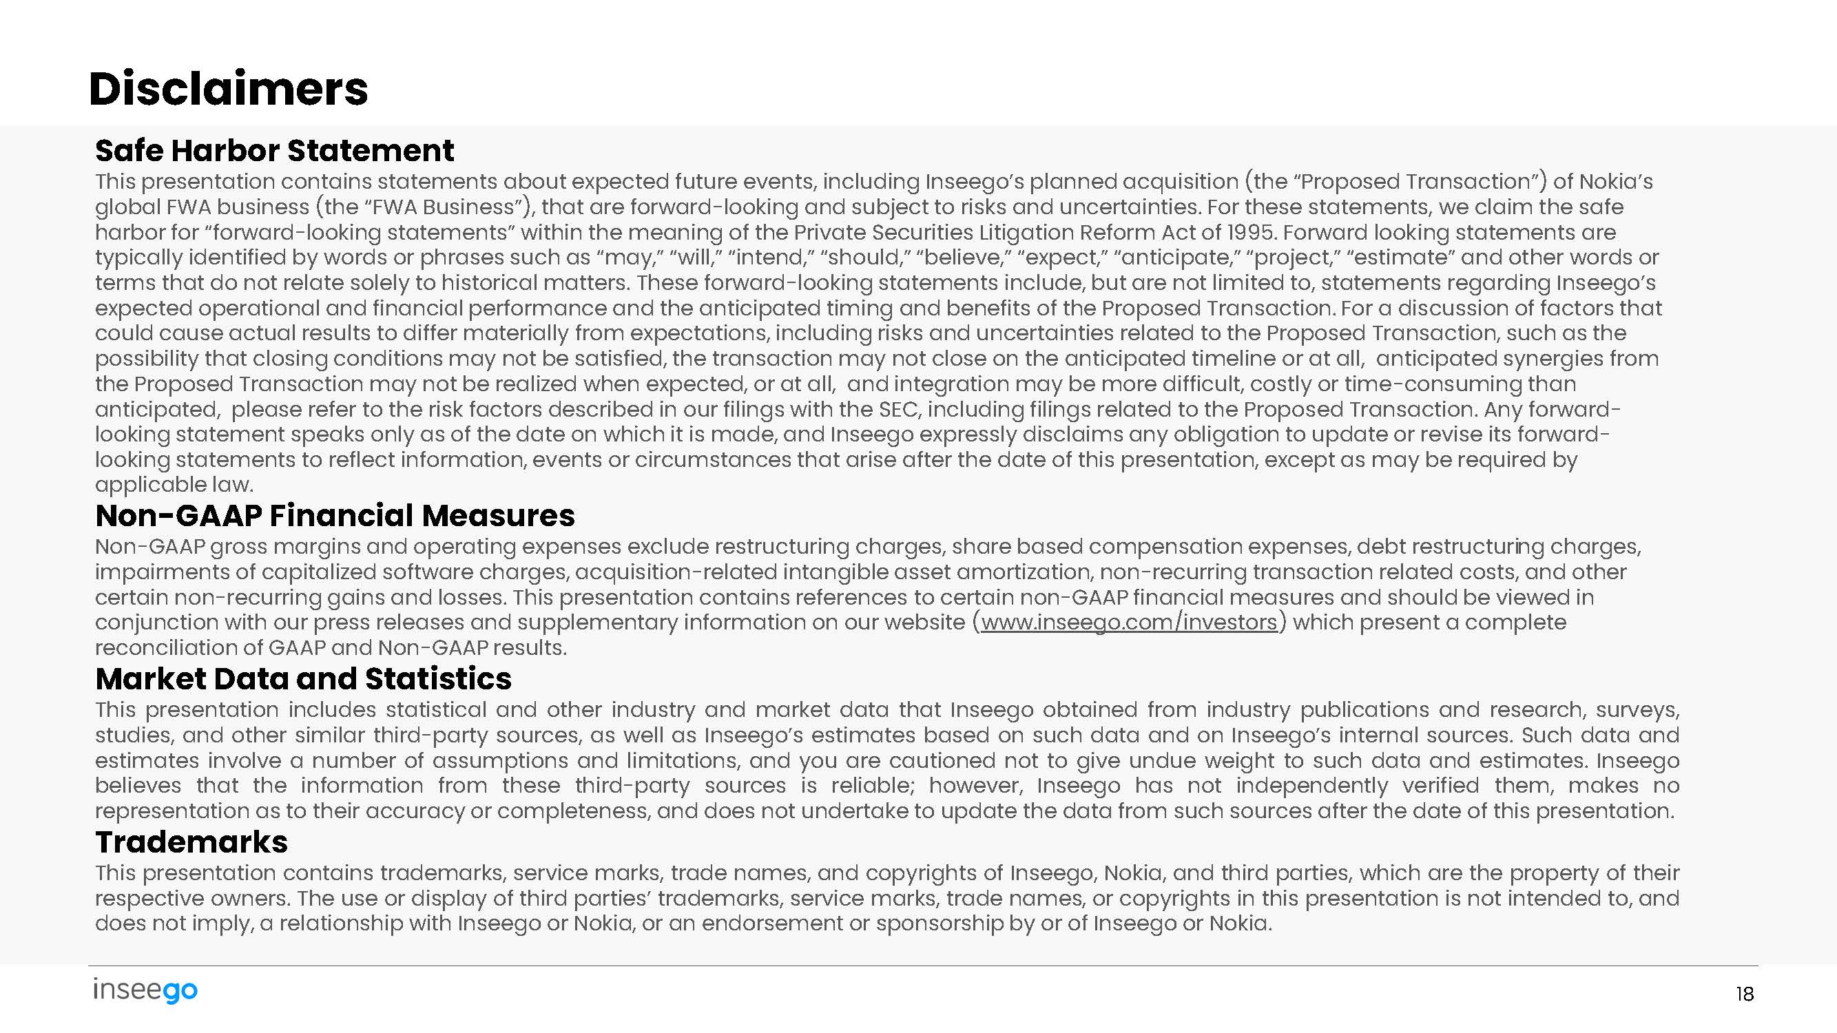
Safe Harbor Statement This presentation contains statements about expected future events, including Inseego’s planned acquisition (the “Proposed Transaction”) of Nokia’s global FWA business (the “FWA Business”), that are forward - looking and subject to risks and uncertainties. For these statements, we claim the safe harbor for “forward - looking statements” within the meaning of the Private Securities Litigation Reform Act of 1995. Forward looking statements are typically identified by words or phrases such as “may,” “will,” “intend,” “should,” “believe,” “expect,” “anticipate,” “project,” “estimate” and other words or terms that do not relate solely to historical matters. These forward - looking statements include, but are not limited to, statements regarding Inseego’s expected operational and financial performance and the anticipated timing and benefits of the Proposed Transaction. For a discussion of factors that could cause actual results to differ materially from expectations, including risks and uncertainties related to the Proposed Transaction, such as the possibility that closing conditions may not be satisfied, the transaction may not close on the anticipated timeline or at all, anticipated synergies from the Proposed Transaction may not be realized when expected, or at all, and integration may be more difficult, costly or time - consuming than anticipated, please refer to the risk factors described in our filings with the SEC, including filings related to the Proposed Transaction. Any forward - looking statement speaks only as of the date on which it is made, and Inseego expressly disclaims any obligation to update or revise its forward - looking statements to reflect information, events or circumstances that arise after the date of this presentation, except as may be required by applicable law. Non - GAAP Financial Measures Non - GAAP gross margins and operating expenses exclude restructuring charges, share based compensation expenses, debt restructuring charges, impairments of capitalized software charges, acquisition - related intangible asset amortization, non - recurring transaction related costs, and other certain non - recurring gains and losses. This presentation contains references to certain non - GAAP financial measures and should be viewed in conjunction with our press releases and supplementary information on our website ( www.inseego.com/investors ) which present a complete reconciliation of GAAP and Non - GAAP results. Market Data and Statistics This presentation includes statistical and other industry and market data that Inseego obtained from industry publications and research, surveys, studies, and other similar third - party sources, as well as Inseego’s estimates based on such data and on Inseego’s internal sources . Such data and estimates involve a number of assumptions and limitations, and you are cautioned not to give undue weight to such data and estimates . Inseego believes that the information from these third - party sources is reliable ; however, Inseego has not independently verified them, makes no representation as to their accuracy or completeness, and does not undertake to update the data from such sources after the date of this presentation . Trademarks This presentation contains trademarks, service marks, trade names, and copyrights of Inseego, Nokia, and third parties, which are the property of their respective owners . The use or display of third parties’ trademarks, service marks, trade names, or copyrights in this presentation is not intended to, and does not imply, a relationship with Inseego or Nokia, or an endorsement or sponsorship by or of Inseego or Nokia . 18 Disclaimers
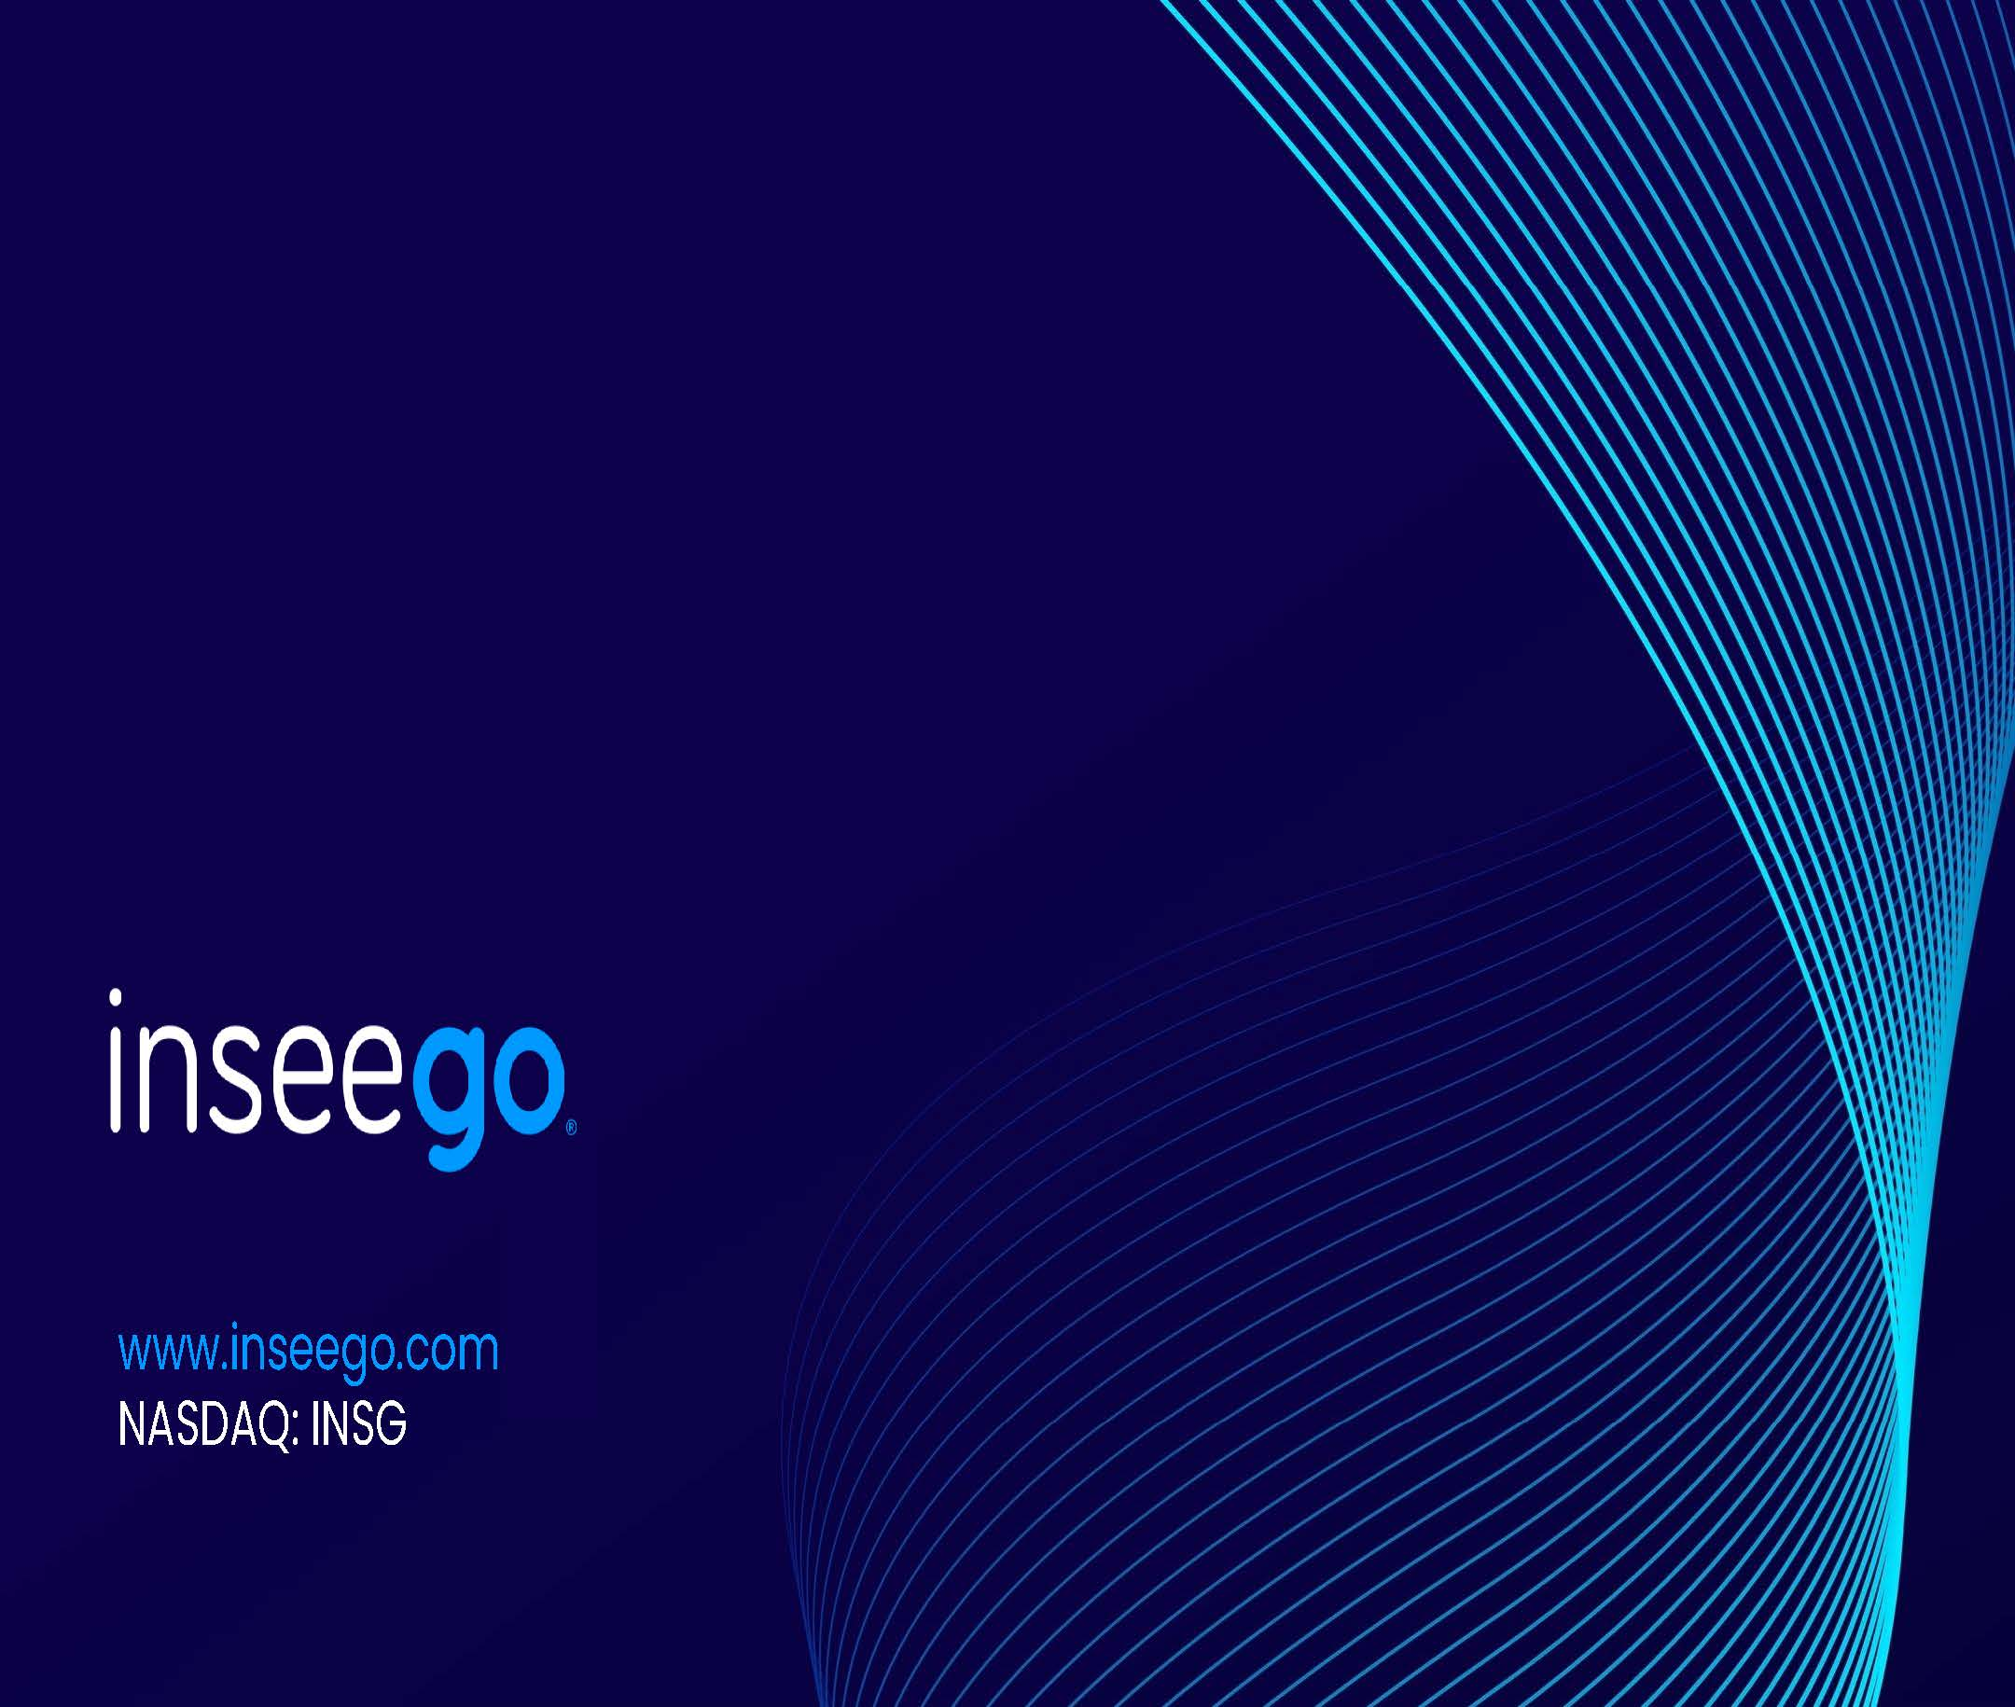
www.inseego.com NASDAQ: INSG

